Detailed Report On Glass Tops For Bedroom Furniture
Imagine the gleam of a smooth glass surface, gracefully adorning your furniture. Whether it's your cozy bedroom or a chic dining area, the allure of custom made glass tops is undeniable. These elegant additions, crafted with precision, can transform the ordinary into the extraordinary. Embrace the concept of replacement glass tops. When the original surface loses its luster, a new glass top emerges as a savior. Tailored to fit seamlessly, it revives your furniture's charm, offering a fresh start. Made to measure glass table tops are the answer. Every table has its unique dimensions and personality. A made to measure glass top, an embodiment of accuracy, ensures that your table is well clothed. It's not just a measurement; it's a commitment to a flawless fit. The bedroom, a realm of relaxation, deserves its own share of glass elegance. Picture glass tops for bedroom furniture, gracefully guarding your dressers or nightstands. The bedroom becomes a canvas of sophistication, with glass reflecting the soft glow of your personal space. Are you looking for glass tops for bedroom furniture? View the earlier mentioned website.

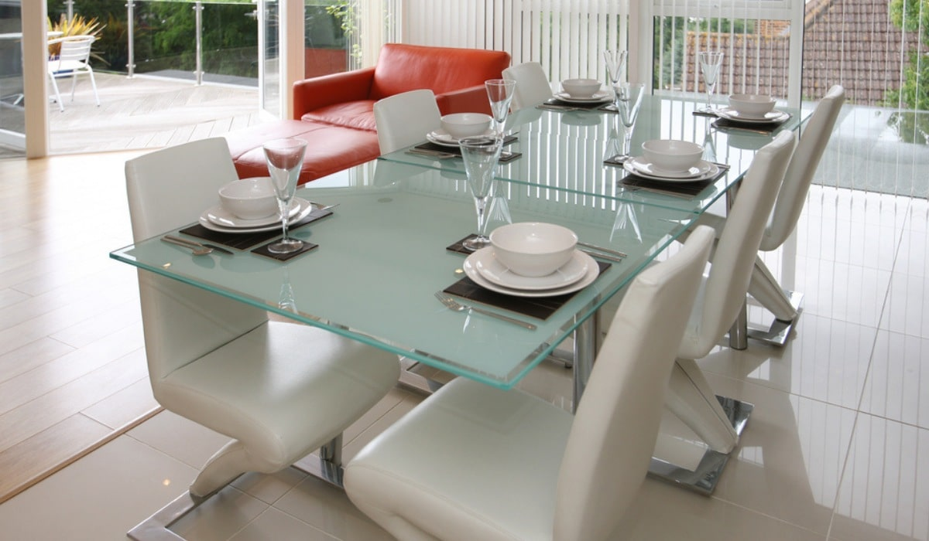

The delicate balance between functionality and aesthetics is beautifully struck. Glass, versatile and enchanting, takes your furniture to another level. The custom made approach extends beyond dimensions; it delves into your personal style. The replacement glass tops bid adieu to compromise, welcoming the new while embracing the familiar. Change becomes an opportunity. Crafting these glass marvels involves a meticulous journey. The artistry lies not only in shaping the glass but also in understanding its destined furniture partner. The glass becomes an extension, an enabler of beauty and function. It's not just glass; it's an expression. The process is a symphony of precision. Every measurement matters, and every edge is smoothed with care. The glass is cut to size, a symmetrical dance that creates harmony.

It's a fitting testament to the saying that details make all the difference. The allure of glass is its ability to merge seamlessly with any ambiance. Be it a rustic wooden table or a sleek modern piece, glass bridges the gap between eras and styles. The transparency allows the furniture's character to shine through, creating a visual delight. A custom made glass top isn't just an addition; it's a statement. It speaks of attention to detail, and a desire to create an environment that reflects your individuality. It's a conversation starter, an exquisite detail that catches the eye and intrigues the mind. In the realm of design possibilities, glass proves to be a versatile medium. It's not limited to a specific room or a particular style. Its universal appeal makes it a canvas for your creativity. With the right glass top, your furniture becomes a living work of art. So, whether you're envisioning replacement glass tops, made to measure glass table tops, or the sheer elegance of glass tops for bedroom furniture, remember that you're embracing more than just glass, you're embracing a new dimension of aesthetics and functionality. It's the art of elevating the everyday, one exquisite glass top at a time.

