A Few Details About Wedding Venue Hire

In the intricate and captivating journey of orchestrating a wedding that lingers in hearts and minds, the pivotal role of wedding venue hire takes center stage. This service, with its profound implications and meticulous attention to detail, is the cornerstone upon which the foundations of an unforgettable wedding are built. Wedding location hire is a profound art that involves the selection and preparation of the perfect backdrop for the forthcoming nuptials. It is the careful curation of spaces that are not just aesthetically pleasing, but spaces that tell a story, spaces that resonate with the couple's personalities and the unique narrative of their love. The essence of wedding venue hire transcends the visual appeal, encompassing the creation of a distinct atmosphere. This is a transformation that takes spaces and transforms them into immersive experiences, carefully adorned with elements that evoke emotions and carry sentimental meaning. It is the interplay of colors, décor, lighting, and arrangement that encapsulates the essence of the day, weaving the tale of love into every nook and cranny. If you are seeking for additional details on wedding venue hire watford, just go to the earlier mentioned website.

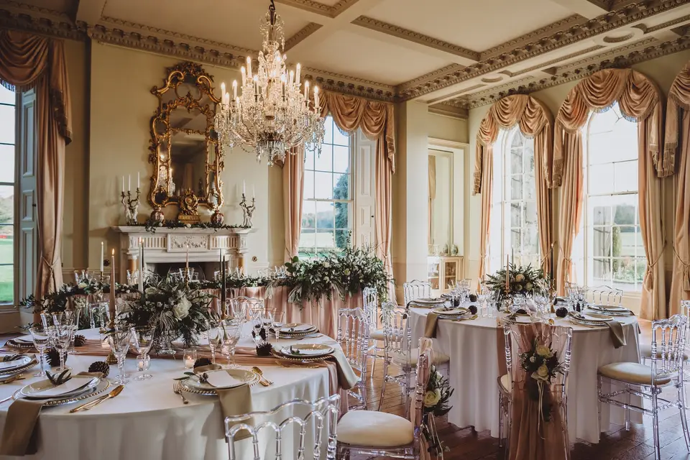

Beneath the surface, beyond the façade of beauty, lies the logistical mastery that wedding location hire entails. The expert teams working behind the scenes ensure that the gears turn smoothly. Seating arrangements, culinary delights, technical arrangements – each cog fits seamlessly to create an experience that is not only visually stunning but functionally flawless. This service liberates couples from the rigors of planning, allowing them to immerse themselves in the celebration. One of the most enchanting aspects of wedding venue hire is its versatility. It caters to both grand celebrations that demand opulence and intimacy that call for a more delicate setting. This adaptability is the hallmark of this service, morphing and evolving to bring to life the dreams and desires of every couple.

Be it an open air extravaganza under the starlit sky or an opulent indoor affair, the canvas is expansive, allowing for infinite interpretations. A remarkable characteristic that sets wedding location hire apart is its gift of timelessness. Each venue holds within its walls a trove of history and stories. In the realm of wedding venue hire, meticulous attention to detail reigns supreme. It is an art that requires an understanding of a couple's aspirations and the skill to bring them to fruition. This service is the bridge between dreams and reality, ensuring that every wish, and every thought, is seamlessly translated into the celebration. The canvas that wedding location hire offers is vast, akin to an open sky. It is a canvas that grants wings to dreams, allowing them to soar to astonishing heights. This service possesses the magical ability to transform bricks and mortar into a realm of emotions, a realm that captures the true essence of love. It operates in the shadows, meticulously weaving the threads of an enchanting day, ensuring that the spotlight remains firmly on the couple and their remarkable journey. In the grand tapestry of wedding planning, the role of wedding venue hire is pivotal.

