An Overview Of Wedding Decor Hire

Marquees, those magnificent specialised tents, have revolutionized the art of event hosting by providing a remarkable solution that ensures guests are sheltered and protected from the unpredictable forces of nature. These extraordinary structures offer complete enclosure, creating a secure haven where attendees can revel in the festivities, undeterred by the whims of weather. The allure of marquees lies in their ability to shield guests from the elements with impenetrable protection. Whether the sun is blazing during a scorching summer day or the air turns chilly as evening sets in, these resilient tents stand tall, defying the elements. Raindrops cascade off their surfaces, creating a symphony of nature's rhythms, while the interior remains blissfully dry, preserving the merriment and keeping spirits high. A hallmark feature of marquees is their adaptability to a myriad of occasions. Whether it's a grand wedding reception bedecked with elegance, a corporate gathering bustling with energy, or a vibrant community celebration pulsating with life, these tents provide an idyllic setting. If you are seeking for additional info on wedding decor hire kent, click on the previously mentioned website.

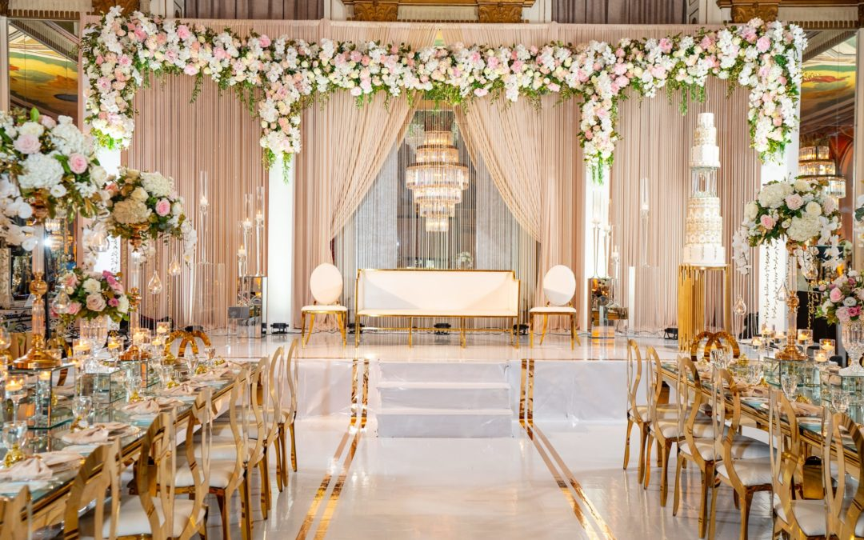

The capacious interiors accommodate diverse furniture arrangements, allowing hosts to craft personalized layouts that cater to their unique visions. Flexibility is a defining characteristic of marquees, facilitating the creation of temporary venues in diverse locations. With ease and efficiency, these tents can be erected and dismantled, granting event organizers the freedom to choose the perfect spot for their festivities. Parks, gardens, private properties—the possibilities are endless, limited only by the bounds of imagination. Inside these transformative tents, the ambiance is further enhanced through creative decor and lighting arrangements. Soft, warm lights delicately illuminate the space, casting an enchanting glow for a romantic wedding reception. In contrast, vibrant and colorful lighting sets the stage for a lively dance floor, beckoning guests to let loose and revel in the joyous atmosphere. The interior walls, akin to a blank canvas, eagerly await the touch of an artist's hand, providing event planners with endless opportunities to manifest their creative visions and orchestrate truly unforgettable experiences. Beyond protection from the elements, marquees offer an invaluable sense of privacy and seclusion.

The enclosed space fosters a feeling of exclusivity, enabling guests to fully immerse themselves in the event without distractions from the outside world. In this intimate setting, connections are forged, laughter resounds, and memories are made, all within the secure embrace of these remarkable structures. In addition to their functional benefits, marquees boast captivating aesthetics. Their sleek, elegant design adds a touch of sophistication to any event. With graceful curves and clean lines, these structures become visual focal points that command attention as guests arrive, leaving a lasting impression of grandeur and elegance. Marquees stand as the epitome of versatile and exceptional event solutions. Their specialized design, ensuring complete enclosure, creates a haven where guests can revel in the festivities, untouched by nature's whims. With flexibility, portability, and unmatched aesthetic appeal, marquees have emerged as the favored choice for those seeking to curate extraordinary experiences, transcending the boundaries of location and weather to create unforgettable memories that will endure for a lifetime.

