A Few Details About 3D Scanning Company

In today's fast-paced world, the demand for innovative design solutions is ever-growing. This is where 3D object scanning services step in, offering a game-changing approach to capturing real-world objects in intricate detail. By harnessing cutting-edge technology, these services enable businesses and individuals to digitize physical objects, unlocking a world of possibilities for industries such as manufacturing, architecture, fashion, and more. In this article, we will delve into the transformative power of 3D object scanning, exploring its benefits, applications, and how it has revolutionized the way we approach design and creativity. High-resolution cameras, laser sensors, and structured light systems work together to capture every minute detail of an object's surface, creating a digital representation in three dimensions. This process involves the precise measurement of geometric data and the generation of a point cloud, which forms the foundation for creating accurate and realistic 3D models. The software algorithms then analyze the captured data and convert it into a usable format, ready for further manipulation or fabrication. Check out the following site, if you are looking for more details on 3d scanning company.

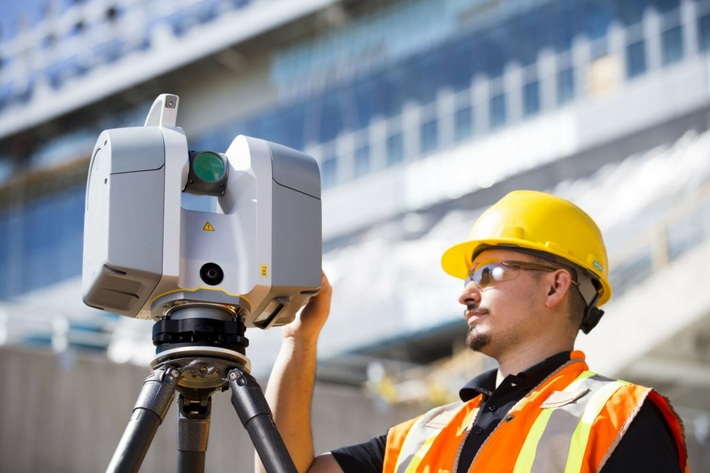

The applications of 3D object scanning are vast and diverse. In the realm of product design and manufacturing, it allows for rapid prototyping, quality control, and reverse engineering. Architects and designers can capture real-world environments and integrate them seamlessly into their digital models. Healthcare professionals benefit from precise anatomical scanning for customized medical solutions. Even the entertainment industry utilizes 3D scanning to bring virtual characters to life in movies and video games. The benefits are far-reaching, including increased efficiency, reduced costs, enhanced accuracy, and the ability to explore new design possibilities. To grasp the impact of 3D object scanning, let's consider a few real-world examples. In the automotive industry, engineers can scan physical car parts and optimize them for weight reduction or aerodynamics. In fashion, designers can create custom-fitted garments using accurate body scans. Museums and cultural institutions can preserve artefacts in digital form, allowing for virtual exhibitions and detailed documentation. These examples showcase the versatility and practicality of 3D object scanning in various fields.

As technology continues to advance, the potential of 3D object scanning only expands. With ongoing developments in machine learning, artificial intelligence, and automation, we can expect even more sophisticated scanning capabilities and seamless integration with design workflows. The democratization of 3D scanning technology also opens doors for individuals and small businesses to leverage its power. The future holds exciting possibilities for design, innovation, and the limitless creativity unlocked by 3D object scanning. 3D object scanning services have revolutionized the way we approach design, manufacturing, and creativity. By digitizing real-world objects with remarkable precision, businesses and individuals gain access to a wealth of opportunities for innovation, optimization, and customization. The applications are vast, from product design to architecture, healthcare, and beyond. As technology continues to evolve, 3D object scanning will shape the future of design, offering new dimensions of creativity and redefining what is possible. Embrace the power of 3D object scanning and unlock a world of endless possibilities.

