Detailed Analysis On The Prepper Food

In an unpredictable world, being prepared for unforeseen occurrences has become increasingly crucial. Prepper food kits, often known as emergency food supplies, are intended to supply individuals and families with necessary sustenance during times of disaster. These kits are designed selections of long-lasting, healthy, and easy-to-store food supplies that ensure survival and peace of mind in the case of disasters. This article discusses the importance of prepper food kits as well as their essential features and benefits. Regular food supplies may not be available or easily accessible due to natural disasters, pandemics, economic downturns, or other situations. Prepper food packages provide a lifeline in such times by providing a consistent supply of sustenance. These kits are useful not only for survivalists or severe preppers but also for everyone looking to protect their own and their loved ones' well-being. Browse the below mentioned site, if you are looking for more information regarding prepper food.

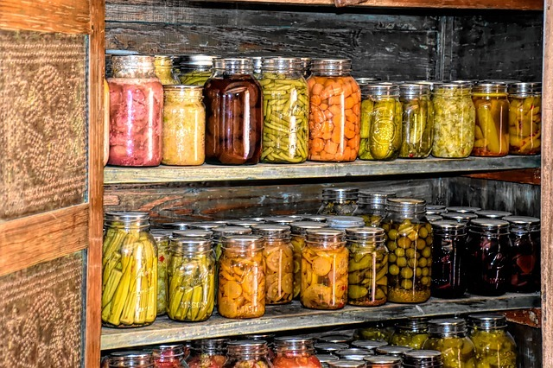

They create a sense of security and self-sufficiency by meeting dietary demands when grocery stores are inaccessible or depleted. Prepper food kits are rigorously created to suit specific criteria such as long shelf life, nutritional content, and ease of use. Non-perishable food products such as canned goods, freeze-dried meals, cereals, pasta, beans, and powdered milk are commonly included in these kits. Food is frequently dehydrated or freeze-dried to improve shelf life and retain nutritional value. Because portability and convenience of storage are critical factors, the kits are compact and packaged in sealed containers to prevent spoilage and maintain freshness. Some kits may include water purification pills or filters to provide a safe drinking supply. Purchasing survival food kits has various advantages. They first remove the need for hurried last-minute purchases amid emergencies, freeing people up to concentrate on other important responsibilities. Second, these kits provide peace of mind by acting as a safety net during times of crisis, alleviating anxiety and stress.

Furthermore, prepper food kits promote self-sufficiency, allowing people to take responsibility for their survival needs. They are also more cost-effective in the long run because they reduce food waste and the need for frequent replenishment. Finally, prepper food packages can be tailored to specific dietary demands, ensuring that everyone's nutritional needs are covered. Preparing for emergencies has become a wise practice as global uncertainties continue to rise. Prepper food packages provide a practical and dependable answer for ensuring sustenance during difficult times. These kits give individuals and families the courage to face crises by offering critical nutrition, convenience, and peace of mind. Having a well-stocked prepper food kit can make a huge difference in ensuring survival and well-being in the event of a natural disaster, epidemic, or other emergency. Individuals can safeguard themselves and their loved ones by taking preventive measures to prepare for the unexpected, producing resilience in the face of disaster.

