A Synopsis Of Gyno Surgery

Gynecomastia, a condition that affects males, can occur at any age. However, it is most commonly observed in young and elderly men. This condition, often referred to as "male breast enlargement," can be a source of distress and discomfort for those who experience it. In young men, gynecomastia often develops during puberty, when hormone levels are fluctuating. The hormonal changes can disrupt the balance between estrogen and testosterone, leading to the growth of breast tissue. This occurrence can cause embarrassment and self consciousness, as young men may feel insecure about their appearance. On the other hand, elderly men may also experience gynecomastia due to hormonal imbalances. As men age, their testosterone levels naturally decrease, while estrogen levels may remain stable or increase slightly. This hormonal shift can result in the development of breast tissue, contributing to the condition. The physical changes can be disconcerting for older men, affecting their body image and overall wellbeing. It is important to note that gynecomastia is not caused by excess weight or fatty tissue. Are you searching for gyno surgery london? Visit the previously talked about site.

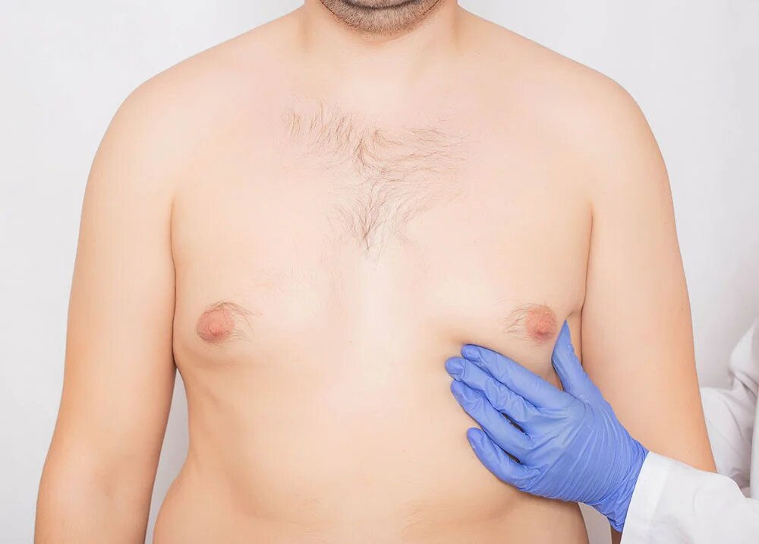

It is primarily attributed to hormonal factors. However, certain medications, such as those used for treating prostate cancer or certain psychiatric conditions, can also contribute to the development of gynecomastia. Hormonal imbalances are one of the primary causes of gynecomastia. Fluctuations in the levels of estrogen and testosterone can disrupt the delicate hormonal balance in the body, leading to the growth of breast tissue. This hormonal imbalance can occur during different stages of life. Living with gynecomastia can be emotionally challenging for affected individuals. They may feel self conscious about their bodies and may shy away from situations that require them to expose their chest. This condition can also impact their self esteem and confidence, leading to social withdrawal. Fortunately, there are treatment options available for gynecomastia. In some cases, the condition may resolve on its own, especially during puberty. However, if gynecomastia persists or causes significant distress, medical intervention may be necessary.

Treatment approaches for gynecomastia vary depending on the underlying cause and severity of the condition. In some cases, hormone therapy may be prescribed to restore hormonal balance. In other instances, surgical intervention, such as liposuction or breast reduction surgery, may be recommended to remove excess breast tissue and restore a more masculine chest contour. It is important for individuals with gynecomastia to consult with a healthcare professional for an accurate diagnosis and appropriate treatment plan. They should feel empowered to discuss their concerns openly, as healthcare providers can provide guidance and support. Gynecomastia is a condition that can affect males of any age, although it is more commonly seen in young and elderly men. The development of breast tissue can cause emotional distress and impact self esteem. However, with the right medical guidance and treatment, individuals with gynecomastia can find relief and regain their confidence. It is crucial to seek professional help to address this condition effectively and improve overall wellbeing.

