A Glance At Corporate Event Flowers
Florist services have become an integral part of our lives, providing a touch of nature's beauty to our significant occasions. These skilled artisans bring life to events, both social and corporate, through their artful arrangements of flowers. With their creativity and expertise, florists play a significant role in enhancing the ambiance and conveying emotions without the need for words. In today's fast paced world, where time is precious, people rely on florists to create stunning floral designs that reflect their sentiments. Whether it's a wedding, anniversary, birthday, or any other special event, florists are sought after to add a touch of elegance and charm. Their ability to transform ordinary spaces into breathtaking scenes is truly remarkable. One of the key reasons behind the popularity of florist services is their skill in selecting the perfect combination of flowers. Each bloom holds its own unique symbolism and meaning, allowing the florist to convey emotions subtly. If you are seeking for additional details on corporate event flowers, view the previously mentioned site.

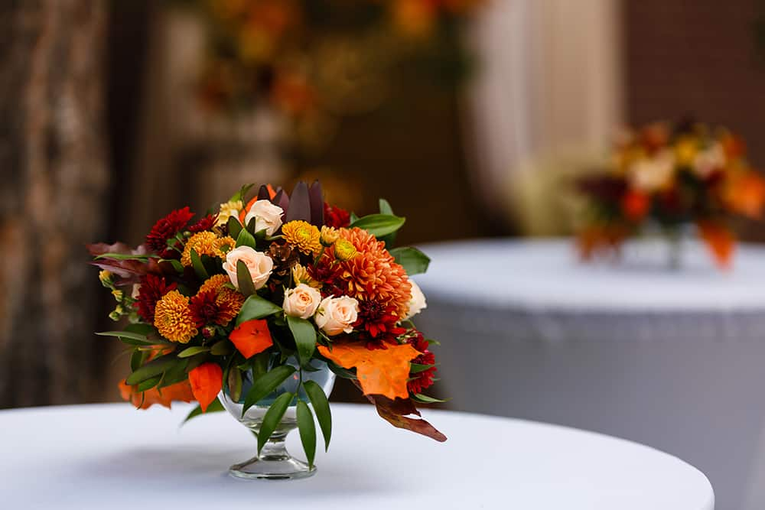

Whether it's the timeless romance of roses, the purity of lilies, or the vibrancy of sunflowers, the florist's understanding of these floral languages enables them to create arrangements that speak volumes. Moreover, florists possess an innate sense of aesthetics. They have an eye for colour, texture, and composition, allowing them to create visually appealing displays that captivate everyone's attention. By carefully selecting flowers of various shapes and sizes, and complementing them with foliage and other elements, florists create harmonious arrangements that evoke feelings of joy, love, or serenity. Florists also understand the importance of personalization. They take the time to understand their clients' preferences, ensuring that the arrangements align with their vision and style. From traditional bouquets to modern centrepieces, florists can cater to a wide range of tastes, making each creation unique and tailor made for the occasion. Furthermore, florists are skilled at not only creating arrangements but also handling and preserving flowers. They carefully source and select fresh blooms, ensuring their longevity and freshness.

By applying their knowledge of flower care techniques, they make sure that the arrangements stay vibrant and beautiful for as long as possible. Beyond their expertise in floral design, florists possess exceptional customer service skills. They understand the significance of the events they contribute to and strive to exceed their client's expectations. With their warm demeanour and attention to detail, they provide a seamless experience from the initial consultation to the delivery and setup of the arrangements. In today's bustling world, florists serve as the conduit between nature's beauty and human emotions. Their artistry and dedication enable them to create extraordinary experiences through the language of flowers. So, the next time you're celebrating a special moment, remember to enlist the services of a talented florist. They will weave their magic, turning your event into a masterpiece that will be etched in your memory forever.

