A Few Details About Teltonika RUT 951

In today's interconnected world, reliable and secure communication networks play a crucial role in the smooth operation of various industries. One essential component of these networks is the industrial router. Although you may not be familiar with this device, it is responsible for enabling data transfer between different machines, ensuring seamless connectivity, and enhancing productivity in industrial environments. An industrial router serves as a central hub, connecting various devices within an industrial setting. Its primary function is to establish and maintain communication between machines, enabling the transmission of data across the network. Think of it as a traffic controller that directs information flow, ensuring it reaches the right destination efficiently. What sets industrial routers apart from traditional routers is their robustness and durability. These devices are specifically designed to withstand harsh environmental conditions commonly found in industrial settings. They are built to handle extreme temperatures, humidity, vibrations, and electromagnetic interference, ensuring uninterrupted network connectivity in demanding operational environments.Industrial routers also offer enhanced security features to protect sensitive data transmitted across the network. They employ advanced encryption protocols, firewalls, and virtual private network (VPN) technologies to safeguard information from unauthorized access and potential cyber threats. Check out the below mentioned site, if you are hunting for additional information about teltonika rut 951.

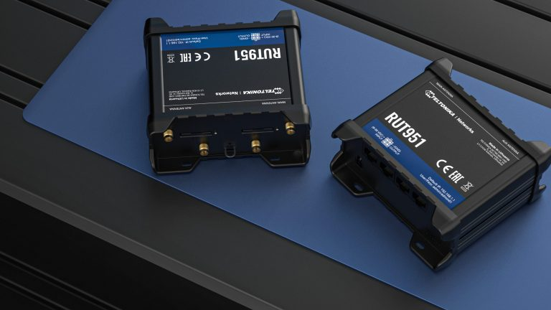
This ensures the integrity and confidentiality of data, a critical aspect in industries where privacy and data protection are of utmost importance. Moreover, industrial routers are designed with scalability in mind. As industrial networks grow and expand, these routers can accommodate the increasing demands for connectivity without compromising performance. They are equipped with multiple ports, allowing for the connection of numerous devices simultaneously. This scalability ensures that the network remains efficient and can adapt to the evolving needs of the industry. The versatility of industrial routers is also worth noting. They can seamlessly integrate with various communication protocols and network architectures, making them compatible with different industrial applications. Whether it's a manufacturing plant, a transportation system, or a utility network, industrial routers provide the necessary connectivity to keep operations running smoothly. Another notable feature of industrial routers is their remote management capabilities.

Industrial environments often span large areas, making it challenging to physically access every router for maintenance or troubleshooting. However, with remote management capabilities, administrators can monitor and manage routers from a centralized location. This enables swift identification and resolution of any network issues, minimizing downtime and maximizing operational efficiency. Industrial routers are critical components in industrial communication networks. They facilitate reliable and secure data transfer, withstand harsh environmental conditions, and offer scalability and remote management capabilities. By providing seamless connectivity and enhancing network performance, industrial routers contribute to the efficient operation of various industries. Whether it's an assembly line in a manufacturing facility, an oil rig in a remote location, or a utility grid powering a city, industrial routers ensure that information flows smoothly, enabling processes to run efficiently. With their robustness, security features, scalability, and remote management capabilities, these devices empower industries to stay connected, productive, and secure in today's interconnected world.

