The Value Of Colorful Mechanical Keyboards

Cute mechanical keyboards are in rising demand these days, and individuals wish to switch their old keyboard models for more efficient ones. Some people feel their keyboard style is affecting their eye vision and hampering their output. This is why they opt for designer keyboards in several themes, colours and designs. Some individuals think only passionate gamers need designer keyboards; this is untrue. Mechanical keyboards are a big hit among work professionals too as they spend a lot of time on their computers. They must update to the newest technology and have a sturdy keyboard for better performance. Often due to overuse, certain keys have to bear the brunt of their typing force. You can choose among the best cute mechanical keyboards online according to your budget and requirements. Automated keywords are cost-effective and sturdier than membrane keyboards. People do not have to worry about spending a lot on cute mechanical keyboards. Are you looking for cute mechanical keyboards? Browse the before discussed site.

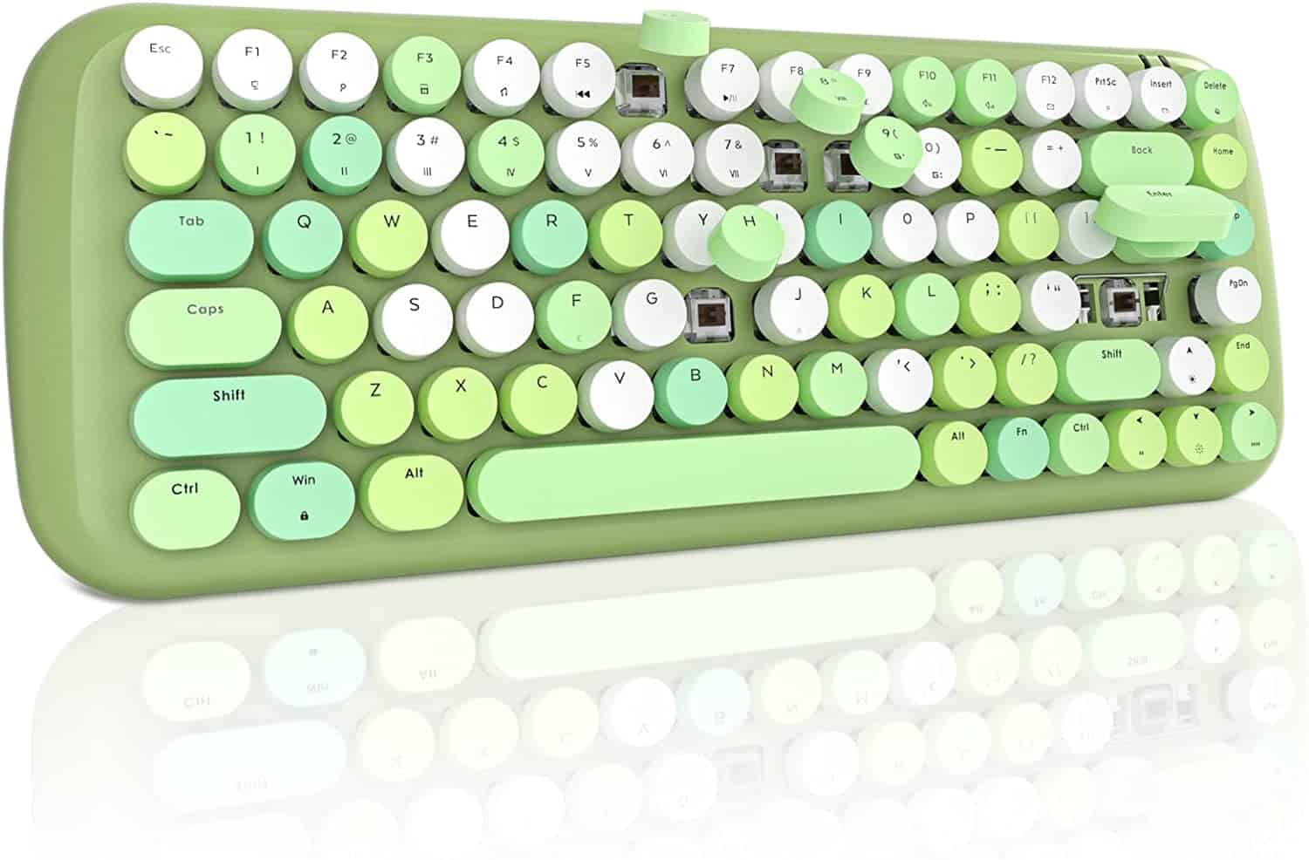
Due to increased competition among manufacturers, you can get amazing deals at your home’s comfort. These are designed keeping the users' best interest in mind. They offer excellent quality; you can use a mechanical keyboard for your computer for all smooth gaming sessions. They can also be used to make your typing lessons more exciting. More and more people are replacing their boring keyboard keys with beautiful colourful ones. They are suitable for long hours and gaming purposes. People can choose any keyboard type according to their needs; according to design, shapes, animation, and logos. Mechanical keyboards combine the latest technology with animation to enhance individuals' experience. These keyboards can be customised according to your specifications. An added benefit of mechanical keyboards is they deliver fast speed and allow users to lessen their mistakes when typing.

They have a quicker response than membrane keyboards and make typing less hassle-free. Due to increased durability and easy key disassembling, these keyboards are easier to clean. If individuals spill anything on their keyboards, they can disassemble the keyboard and clean them quickly. This allows users to avoid expensive repairs. People can find what they are looking for and choose any keyboard colour which suits their preferences. They can go for LED display keys or choose pastel colours like white, pink or mauve. Mechanical keyboards include cutting technology and offer money’s worth. They are lighter to touch and improve your typing speed. With improved control, people can lessen their chances of accidentally hitting a key too hard and mistyping. Choosing the right keyboard can be a personal experience; many gamers prefer mechanical keyboards as they are more tactile, durable and faster. Coloured keyboards improve the overall look of your computer setup with their LED. This is why many people consider them over the regular ones.

