Detailed Look On Metal Bunk Bed

For most homeowners, beds are essential furniture. This is why, they wish to pick the perfect ones for their families. Often people live in small apartments or have limited room space. They want to use their space perfectly when it comes to furniture items like beds, desks and bookshelves. Many people are opting for metal bunk beds. They go with the room’s decor and allow you to add to your house’s value. Metal beds are designed to offer maximum comfort to the clients, and people do not have to worry about triggering allergic reactions in their kids. Often homeowners complain that their wood beds are loaded with chemicals and cause repeated coughing fits. Some people cannot stand the strong smell of chemicals, and some feel uncomfortable on wooden beds. Heavy-duty metal bunk beds are safe, non-toxic solutions, and are also cost-effective. They have a strong metal frame and are low maintenance. Often individuals worry about their wooden beds requiring polishing and repairs. Click on the following website, if you are searching for additional information about metal bunk bed.

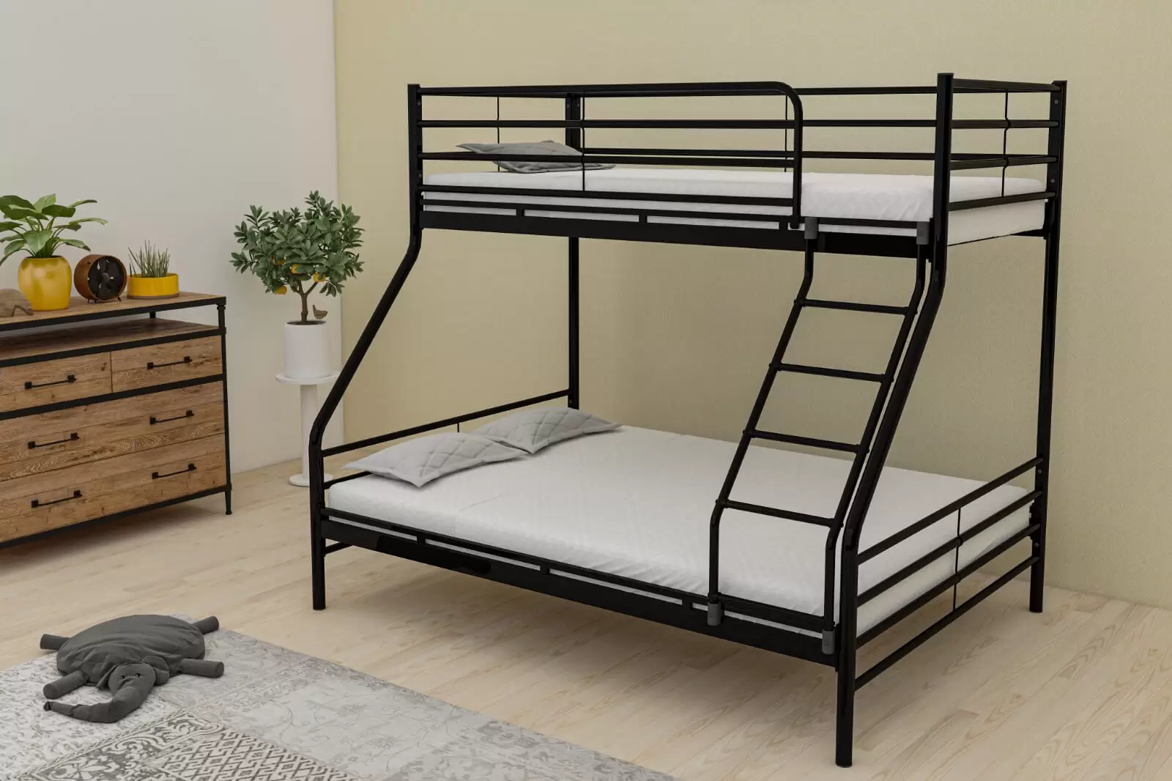

On the other hand, metal bunk beds stay the same for years to come and are more durable. People can wipe them with a wet cloth and retain their shine. Home decor experts feel many of their clients are looking for a sturdy bedding solution and investing in metal bunk beds. Contrary to popular belief, the industry for metal bunk beds is booming these days, and manufacturers offer several dimensions and designs to their users. People can choose any metal bunk design which suits their room decor and budget. Metal beds are moulded in diverse designs according to your room’s needs. Most individuals think bunk beds are kids' furniture, but this is untrue. Due to a lack of space in their rooms, many homeowners can opt for adult metal bunk beds. People can find metal beds according to their room’s colour theme.

They can invest in modern designs or go for traditional or contemporary designs according to their preferences. Metal bunk beds for adults have a strong client base and are most in demand. They are available in various colours and have a sturdy build. Metal bed frames can withstand the weight and are a better option. Individuals can combine their metal bed frames with comfortable mattresses and enjoy a good night’s sleep. Bunk beds are available in several dimensions. People can find metal bunk beds for sale online and get the best deals. If you wish to go for bed frames that can withstand weight and fit perfectly in your room, you can invest in metal bed frames. These beds can withstand large mattress weights and make your sleep more relaxing. Metal bunk beds are an ideal addition to the kids' and parents' rooms and can be painted according to the room’s theme.

