Construction Site Toilets - An Overview

These days, it is important for construction companies to offer complete facilities and amenities to the construction workers if they want them to perform better. This is why more and more construction company owners are taking the services of portable loo hire companies to provide loos to their workers. There are several benefits of opting for portable loos for your site workers. First of all, they maintain the surroundings and help you comply with laws. Installing a portable loo on the work site can work wonders and increase the construction workers’ productivity levels to a great extent. With work site toilets, construction workers do not have to worry about going from one place to another if they wish to freshen up. This allows them to work efficiently and meet the project deadlines. Portable loos are easy to use and clean. Browse the following website, if you are searching for more details concerning construction site toilets.

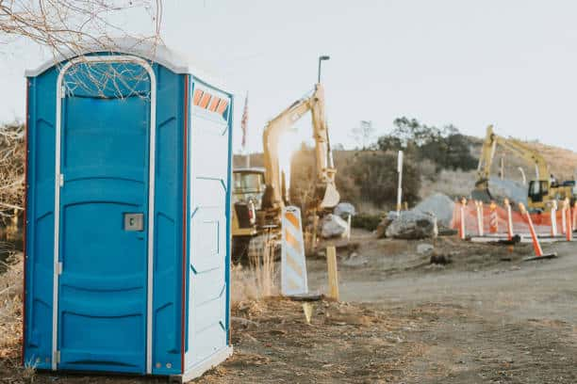

People can choose among several mobile loo models on the mobile toilet company’s website and ensure their construction workers get a clean loo which allows them to freshen up. Portable loos keep your construction workers happy as they do not have to worry about using public loos. This saves travelling time and allows them to complete the construction project on time. Toilet and attendant hire services are the best combination and allow people to enjoy added cost savings. Portable loos ensure sanitation on your site and help avoid health risks. Exposing the construction workers to potential health can risk bacteria and microorganism exposure and make them sick. If most construction workers fall ill, you will be unable to complete your construction project on time. This will increase your budget, and you will have to spend more money from your pocket. Portable loo companies have worked with several homeowners, event organisers and construction businesses in the past and have a friendly team on board.

You can choose among several mobile toilet models available on their website. Portable loos guarantee all your site surroundings and nearby areas are clean. This ensures people do not have to deal with angry neighbours or worry about violating any health protocols. Mobile toilet companies work in the best client interests and have a transparent fee structure. Their price depends on the number of loos and added amenities. With mobile toilets, individuals can protect their construction workers' privacy and allow them to freshen up in between the work. This helps relieve stress and ensures your dream project will be completed on time. If you wish to provide a better overall experience to your construction team and keep the planet healthy, you can hire portable loos services. Their toilets are easy to transport and install After the project is completed, their team will pick up the toilets from the location. Overall, it is a very seamless experience.

