Canvas Bell Tent - Find The Reality About Them

Along with sleeping bags, camping tents are standard equipment for campers. Every trailer would only go out with a tent. Camping tents are portable shelters small enough to be folded or rolled and carried by one person. Tents consist of a sheet of fabric of similar material draped over or attached to a frame of poles. Modern tents have durable waterproof fabrics and foldable aluminium poles. Camping tents vary in size. Some are large enough to sleep one person. Others are quite large and can sleep a whole family. Modern camping tents can be pitched in five to ten minutes. Although camping tents are designed to be tough, rugged, and durable to stand against nature's elements, they are not maintenance-free. Camping tents will last as long as their owners take care of them. Maintaining the quality of camping tents is essential; a tent is usually the only thing that stands between a camper and survival. Are you hunting about bell canvas tent? Visit the previously mentioned website.

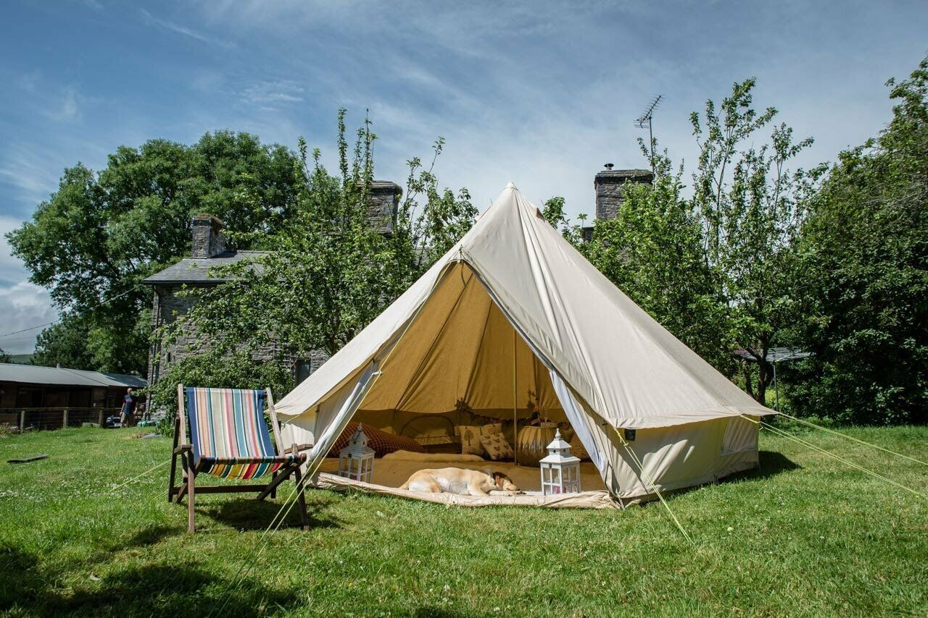

Camping tents should be waterproofed. Most tent manufacturers indicate that their tents are waterproof, and all the seals and stitches are sealed. However, it would be better if you double-seal them for additional safety. Expert outdoorsmen recommend contacting the manufacturer and using the seam sealer the company is using to reseal the seals. Bring extra parts when camping. Bringing extra zippers, duct tape, fabric, and other materials will help you repair the field. Remember that the longer it takes to repair the damage, the greater it will become. Practice setting up the tent. By practising how to set up your camping tent, you will have a lesser chance of ripping, bending, or breaking parts of the tent. It will also allow you to set up the tent quickly. Bring the correct states and use them. Stakes help secure the tent to the ground. Regular stakes are adequate if you are camping in good weather and on firm ground.

Sturdier stakes are required if you are setting up in loose soil or if the weather is windy. Make sure that the correct tension is applied to the stakes. Avoid setting up camping tents in direct sunlight. Even if camping tents are advertised as all-weather, they take damage from direct exposure to the sun. UV light from direct sunlight weakens and deteriorates the fabric of the tents. Therefore it is best to set up tents in the shade. Use ground cover. Before setting up a camping tent, it is recommended that a tent footprint or tarp be placed on the ground where the tent is pitched. This protects the tent's floor from dirt, rocks, twigs, and other objects that can rip the base. It also helps keep the water on the ground out of the tent. Ventilate the tent properly. Moisture can accumulate inside a tent. Opening a window or a flap will keep the inside of the tent from condensing after each use; thoroughly clean and dry the tent. This prolongs tent life. Remember that camping tents are like fine wine; with proper care, they improve with age. Check out your online sellers' website for more tips and information about Camping Tents.

