All You Want To Know About The Wedding Florist

It is the dream of every couple to execute a successfully planned wedding. While it sounds easy, planning a wedding requires a lot of time and effort. Everything needs to be in place; this is why most people hire a professional wedding florist. Professional florists are people associated with the floral industry and know everything about flowers. So, if you are someone who has no idea which floral arrangements will go the best with your event theme, it is best to hire professionals rather than spoiling your big day. You can book in-person consultations with the professional florist to ensure everything goes perfect on your wedding day. Florists are well-versed with all types of flowers available and can help you with the best floral arrangements according to your decor. Popular wedding flowers include peonies, roses, dahlias, lilacs and hydrangeas. Go to the below mentioned site, if you're searching for additional information regarding wedding florist somerset.

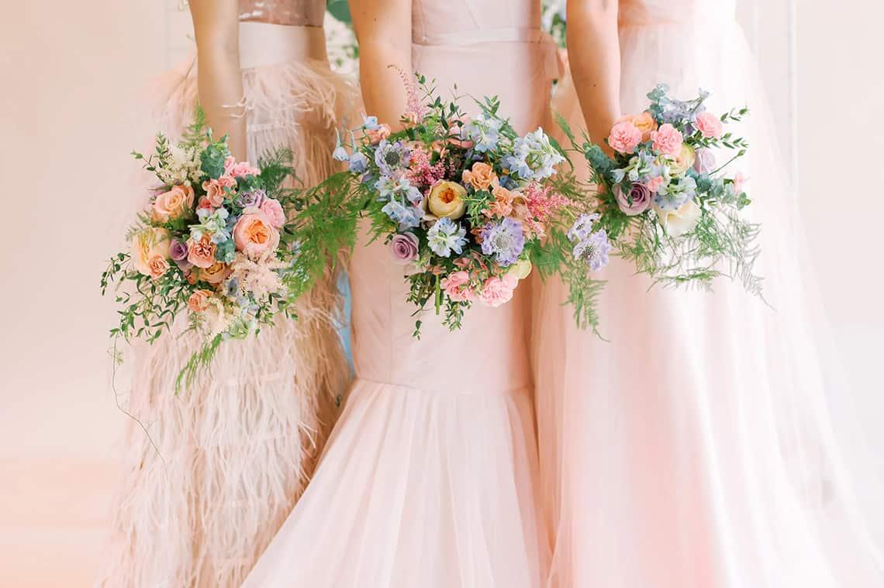

Some people wish to keep things traditional and go for an all-white wedding theme, while others prefer to add a dash of colour to their wedding theme. A good florist can cater to all your needs and ensure you have best-quality flowers to make the occasion perfect. The top reason why hiring a wedding florist will work in your best interest is it allows you to seek professional advice. Wedding florists are experts in their field and have experience to deal with several requests on an everyday basis. They have better flower knowledge than an ordinary person. Thus, they can help you bespoke flowers within your budget. They can also play with different styles and combinations for the best results. Florists can cater to both small-scale and large-scale weddings and corporate functions. They can customise their floral arrangements to ensure their client's needs are met.

Florists work well with their client's ideas and take the stress off their shoulders. Hiring a wedding florist allows people to have their floral arrangements needs taken care of. This way, they can concentrate on other arrangements. If you are tired of the same monotonous flower options and are looking for more variety, you need to hire a skilled wedding florist. Flowers are most at weddings as they are associated with positivity and good luck. Wedding flowers are auspicious and help set the guest's mood. They blend well with the decor and make the venue look more beautiful. Flowers promote sensory stimulation and refresh the guest's spirit. If you wish to have social-media-worthy wedding pictures and ensure your wedding is the talk of the town, you can take the services of a professional wedding florist. They have several tips and tricks up their sleeve to make your wedding extravagant.

