A Look At Lighting Hire

When planning your wedding, consider the significant elements, such as location, flowers, and music. One thing that many couples need to give more consideration to is the lighting for their wedding. Take it, though, because the lighting is one of the easiest ways to create an instant mood. Once you have determined your basic wedding theme, you can start to think about what type of lighting you would like. The key to lighting a space is to balance out the need for people to see clearly to create a romantic and intimate mood. Your room will play a significant factor in this. Look at your reception venue to see what you will be working with. Try to visit your site at the same time of day as you will be holding your reception. This can be critical; if you pay an afternoon visit to a spot with great natural light but are having an evening wedding, it may look completely different. What if their idea of lighting a space is to turn on a couple of flickering fluorescent fixtures? That will certainly not create a romantic glow! Are you searching about hire lighting for a wedding? Look at the before talked about site.

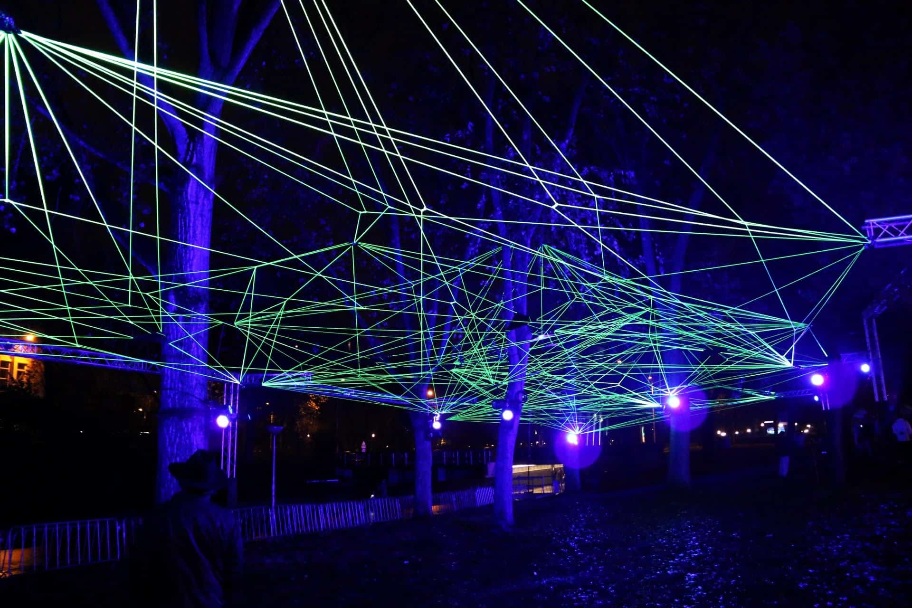

When the distance you will be using for your reception doesn't have the most outstanding lighting, many things can be done. If the problem is severe, you should hire a specialist to assess the site and give you recommendations. In places where the lighting could be better but is just not what you want, there are plenty of things that you can do on your own to make it better. An easy place to start is with candles. Lots and lots of candles. For any evening wedding, their flickering glow will create a beautiful mood in a flash. The best part is that everyone looks better in soft candlelight. Think about how lovely the bride and her bridesmaids will look with the glow of candles dancing on their crystal bridal jewellery sets and putting a twinkle into their eyes. When decorating with candles, you have many choices. If you are a bride who likes traditional gowns and classic sets of pearl bridal jewellery, then elegant tapers set into an elaborate candelabra will suit your style.

On the other hand, if your wedding day is about creating a serene Zen-like environment, float a few candles in a low-water dish. There is more to lighting than candles, of course. Other types of lighting fixtures to bring in include chandeliers, paper lanterns, and hurricane lamps. Each will create an entirely different mood from the other. The chandeliers are pure elegance; the paper lanterns are festive and can be used for an informal atmosphere or a light-inspired reception. The hurricane lamps are ideal for an outdoor evening wedding. Dress them up with a beautiful floral wreath around the base. Coloured lighting can be used for theatrical effects. A gentle pink glow washing over your reception would be flattering and romantic. For a more striking look, you can use spotlights of bolder colours like purple. Sheer-coloured fabric can also be draped in front of white lights to transform them completely. This is an excellent solution for unsightly lighting fixtures.

