Outdoor Wedding Games Hire - An Introduction

People can hire a party photo booth to make their event happening and keep their guests busy. Everyone loves clicking photographs on all occasions and especially at weddings. Therefore, individuals opt for party photo booths at their weddings and events to provide guests an opportunity to click the best photographs. You can have a photo booth at your event for many reasons. Firstly, it enables guests to enjoy the event and promote it on social media. You can rent photo booths as they are inexpensive and make beautiful photos. Hosting a successful event requires a lot of pre-planning. Many people don't want to deal with the planning and hire party planners. But, if you are tight on budget, you can plan a successful event yourself with the assistance of event-hire companies. Online prop rental services encourage responsibility and allow guests to mix. Make a search on the below mentioned website, if you are seeking for additional information concerning lawn games hire.

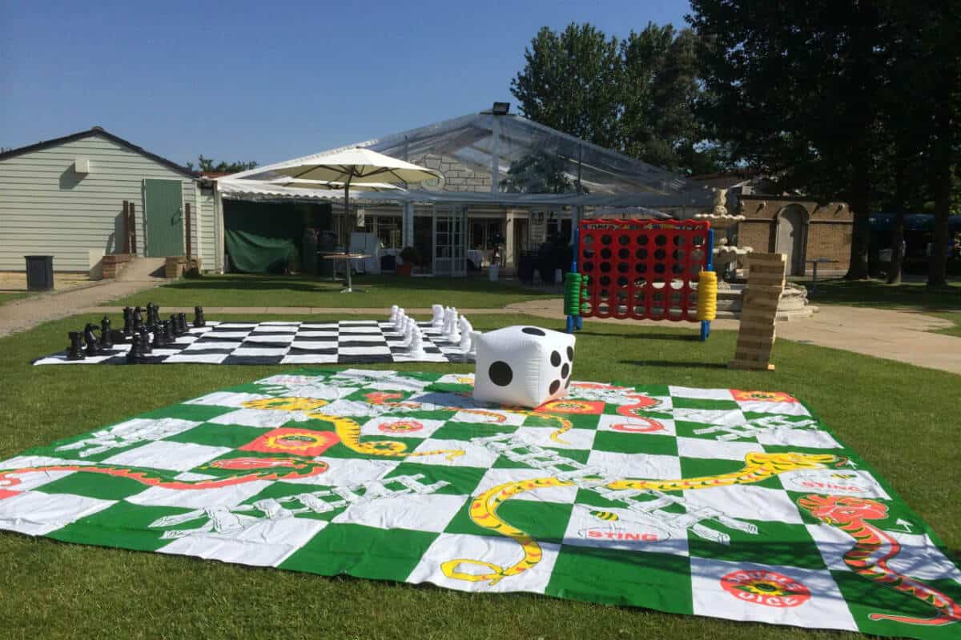

If guests want their photos taken, they don't have to pose in front of professional photographers. A photo booth is a great way to save money on your event without hiring a photographer. The cost of the booth is half that of a photographer and allows your guests to take lots of fun pictures. Party props make a great entertainment option for any occasion. It is possible to create custom props that match the theme of your event and make sure everything looks amazing. Party prop suppliers are able to deliver fast and at lower prices across all product categories. Hence, people can plan an event without breaking their savings and be labelled as a successful host. Hire companies for wedding props have detailed discussions with their customers and work within their given budget. They can deliver the items to you if you give them a list of items.

This allows you to breathe easy and everything is ready for you on time. Photo booths make it easy for guests to capture special moments. You can shop online for props and order what you need. There is a range of decorations and party essentials that you can find there. You can rent small star marquees or sequined cushions for your event. Party props are a great way to make your event memorable and offer something for people to talk about after the event is over. You can rent high-quality decorations, props, and furniture to make your party the talk of town. Often people host events in their homes which do not have ample sitting space; if you do not want your guests to be left standing in a corner, you can hire party furniture. It will add style to your event and make it stand out. Photo booths can often be outfitted with touch screens or LED lights to make them more party-friendly. Party prop hire services help people keep the guests awestruck and ensure each attendee makes the most of their time. You can hire the most fun props to capture your memorable moments and add excitement to boring parties.

