Facts On Waste Collection

Improper waste management can be an issue if you own official premises. Working in clean premises is something very important to maintaining a hygienic environment. This is why several companies hire professional waste collection services. This is why people take the services of professional waste removal companies to keep their surroundings clean. No matter what your budget, you can get certified waste removal service suitable for your needs.The biggest reason rubbish removal services are gaining popularity is that they are efficient and reliable. When individuals handle their waste themselves, they make a lot of mistakes and cause environmental damage. In comparison, rubbish collection and disposal companies know how to sort between recyclable waste and electronic waste. Check out the following website, if you are hunting for additional information on hastings waste collection.

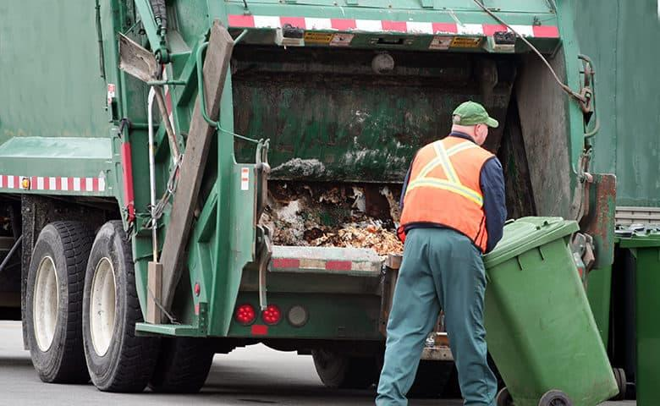

They know the latest rules and regulations governing waste management and customise their services to suit their clients’ needs.An added benefit of hiring waste removal companies is they use the latest technology and eco-friendly ways. They have the right equipment, people and resources to assist their clients. You can pre-book your appointment and feel relaxed during the entire process. Rubbish removal services use the proper techniques and adhere to the government's rules. Waste removal services offer hourly, weekly and monthly services to their clients. You can count on your rubbish removal service provider to get prompt services without causing a dent in your budget. They can help you ensure your employees’ safety and government compliance.

Often people wish to take care of their waste themselves but are worried about the health hazards and toxic gases. A professional waste removal company has workers equipped with PPE kits, masks and gloves to handle waste. They are insured and offer emergency waste removal services to their clients. Waste removal companies offer rubbish segregation and disposal services. Often people do not know what to do with their waste and which type of waste they are dealing with. This is where a rubbish removal company comes in; they are experts and cause a minimal environmental impact. You can use commercial waste removal services for your companies and factories and opt for residential waste removal services for the homes and apartments. Before choosing any waste removal company, you should check their client rating and ensure they work to lessen the carbon footprint. With increasing dependence on technology, people are creating radioactive and electronic waste in huge quantities. If you have your hands full of e-waste and do not know how to deal with it, you can contact a professional junk removal company. They use safe and effective waste disposal techniques. Rubbish removal services start and finish their work on time. They offer quality services to all clients and help people be responsible citizens.

