Facts About Bell Tent For Sale

Many people choose to go camping when they are stressed. Gone are the days when people had to go from one camping store to another in search of quality canvas tents. People can now shop online for certified tent supplies and browse through excellent camping equipment. Users can add the equipment to their cart, make a secure online payment and get them delivered to their doorsteps. Tent companies offer next-day delivery and can ship the items to their customers. This is an enormous help for those who need to plan a camping trip immediately and want to get away from their hectic lives. Bell tents are a popular choice among campers. To enjoy a luxurious camping experience, bell tents are highly sought after. The top reason bell tents are popular among campers is that they are easy to set up. It is easy to transport heavy tent equipment with you wherever you go. Click on the following site, if you are looking for more details regarding bell tent.

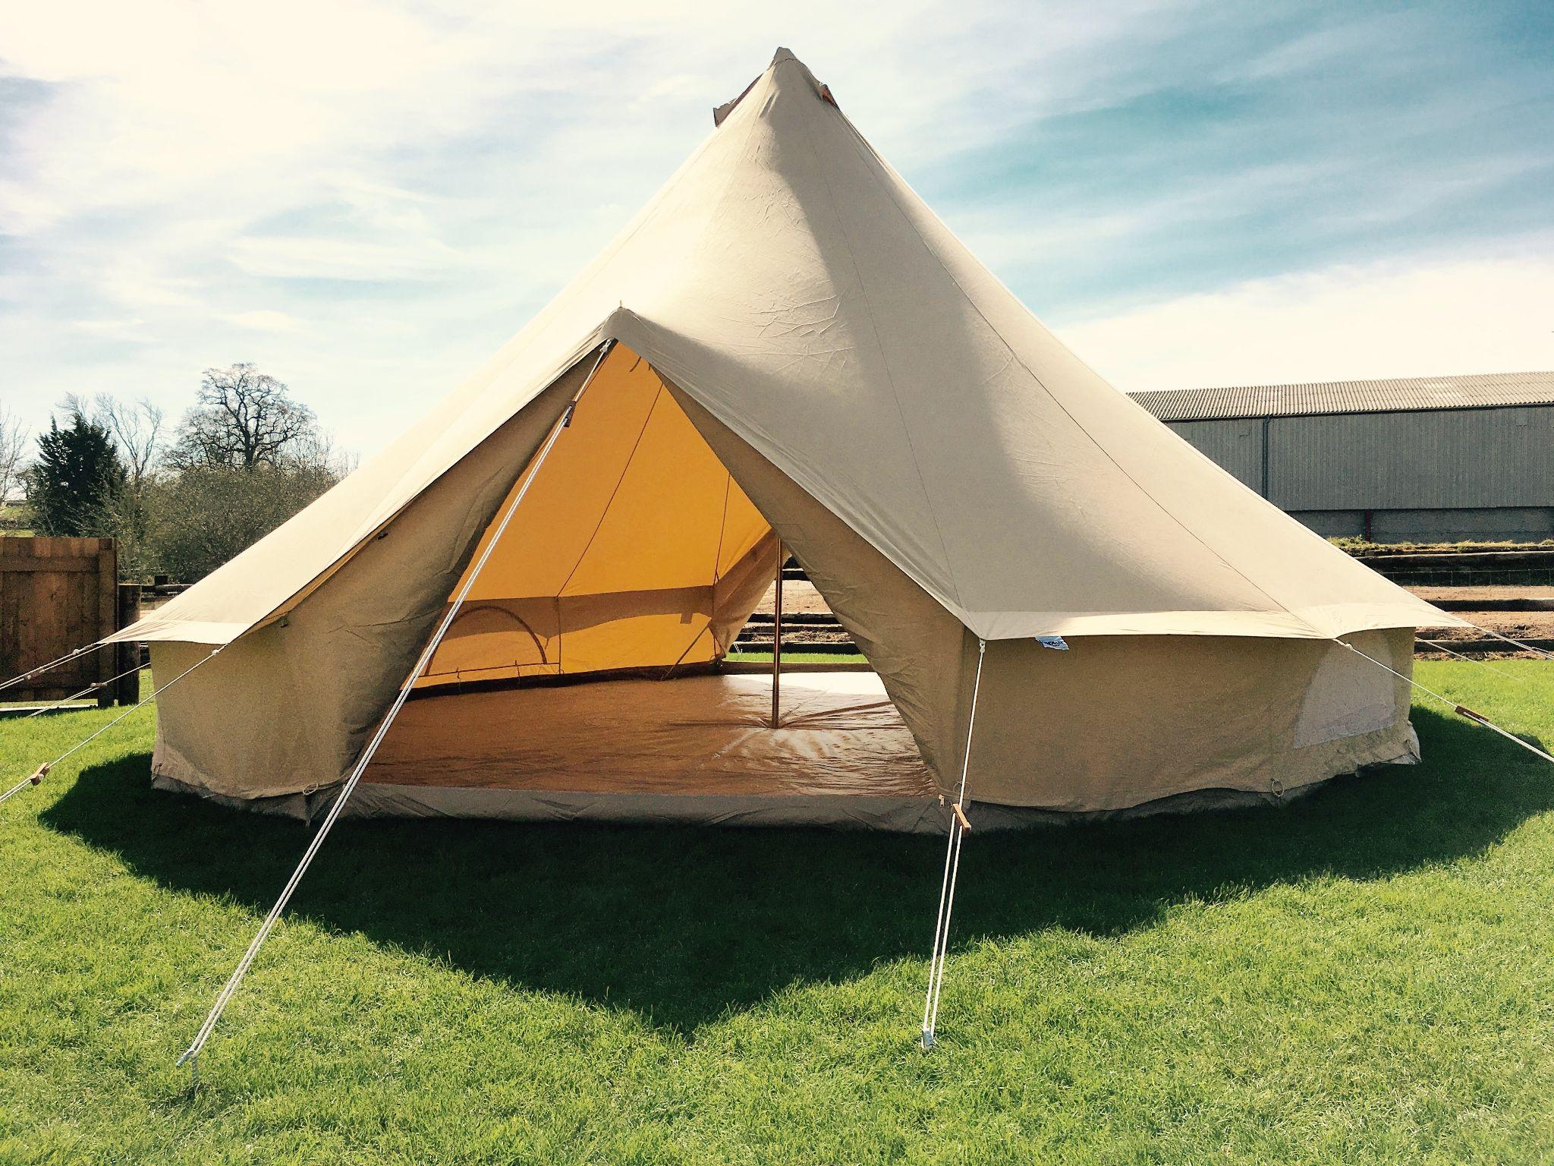

Bell tents can be carried easily and can be taken anywhere. Bell tents can be purchased if you're new to camping or aren't sure which tent you should choose. Bell tents can be carried easily, making them ideal for camping trips. You can order a variety of sizes and styles online. If you're unsure which size is best for you, the tent provider can provide product recommendations. Everyone desires to go camping. But, nobody wants the hassle of pitching large tents in remote locations. Tent manufacturers are able to provide durable, high-quality tents with the latest technology. These tents are light-weight and easy to transport. This is great news for those who want to go camping with their friends and families. Psychologists and mental health experts often recommend camping to people to improve their mental health. People can opt for camping individually or go with friends.

Online tent suppliers help buyers make informed purchasing decisions. You can purchase canvas tents online and take them from one place to another conveniently. People can rent or purchase a canvas camp tent according to their camping trip length. They are more affordable and can be stored quickly, so people prefer to order their tents online. They will feel relaxed and comfortable in their tents. Camping can provide a great way to relax. People no longer have to wander from one store to the other in search of camping equipment. Canvas tents are durable and can protect campers from insects, snakes, and weather changes. They were first used in world war because of their high resistivity and currently are being used in camping due to their reliability. You can therefore invest in a sturdy camping tent without worrying that it will be replaced.

