Individual Guide On Festival Production

Event production companies are responsible for managing all aspects of an event. Individuals have to make tremendous efforts to create an event successfully. Be it any event, whether corporate or personal events, they demand extreme attention. Irrespective of whether it is an extravagant event like a wedding or a general event like a birthday, it needs to be well-planned so that nothing blows up in the end moment. Event management can lead to a lot of stress. Event production companies are the ideal solution. A professional event producer can help reduce stress levels. Therefore, they can enjoy quality time with the other guests rather than stressing out. Many elements must be coordinated and managed if an individual hosts live events. Some crucial aspects are light, music, stage preparation, and video making. However, once an individual hires an event production company, all these aspects are coordinated efficiently by the team. The event production crew is skilled and can fulfill this role efficiently. Are you looking about full festival produciton? Check out the before described website.

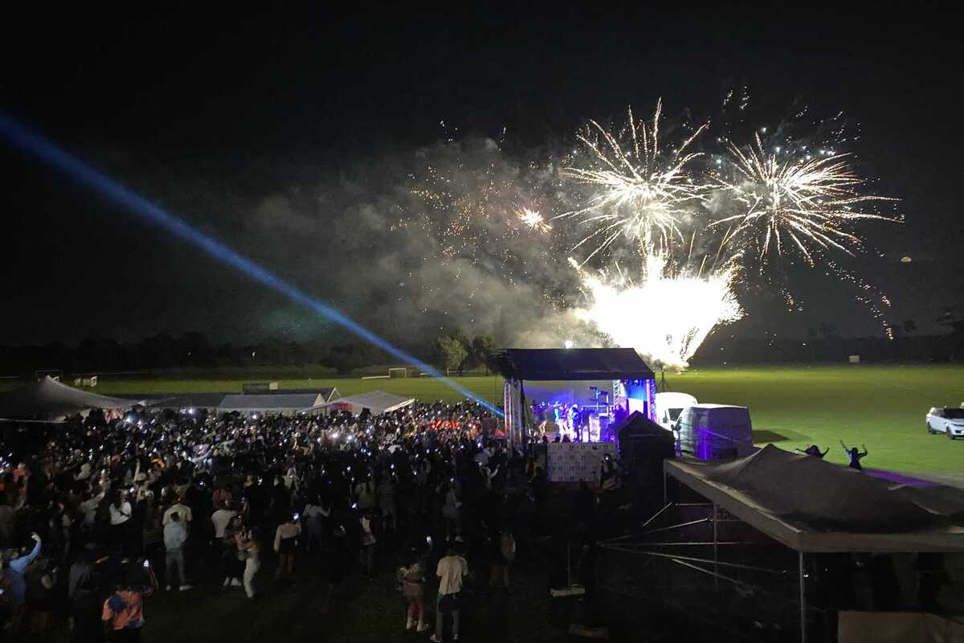

Apart from all that, they can also enjoy a significant amount of time and money. Event production companies have relationships with many vendors and dealers. The event production company has ties with various vendors and dealers. This allows them to identify the best source for getting everything set up. Furthermore, they also take more time to complete the tasks. So, it's a wise decision to hire an event company. Event production companies offer their clients access and use of high-quality equipment that can be expensive and difficult to obtain. The latest in audiovisual, staging and lighting technology is available to you all in one place. Event production companies work to your needs and expectations. Besides, they know how to connect the event theme with the audience and the overall surroundings. It creates an unforgettable atmosphere, making the event memorable.

A team of event producers includes many creative and skilled individuals. Therefore, creativity is served at its best, and individuals can expect top-notch services. Event production companies don't compromise on quality. This is why the event will stand out. It is also a good idea to mention the fact that hiring an event production firm can help you avoid unnecessary stress. They are able to manage everything. Aside from their excellent management skills, the creative team also assists clients in every way possible and gives everything they have to give. Thus, for an extraordinary event, it is suggested to go ahead with a well-known event production company. Event production companies are skilled at managing parties so hosts can relax and enjoy the event.

