A Look At 3D Object Scanning Service

With the increase in customer demands, all companies strive to do their best and foresee their manufacturing in the best possible manner. Reverse engineering is being used by many production companies to verify product quality. In layman's terminology, reverse engineering describes how people can understand the history of the product. Companies are now able to include new elements in their products with the help of advanced technology. This allows them to be more popular with customers. This is accomplished by analysing and analyzing the equipment and previous services. Companies can use reverse engineering technology to stimulate creativity and develop new products for clients. Engineers don't have to invest a lot of time or energy creating new products with emerging technologies. Companies can compare their new products with old ones through this technique and see how they are superior. Click on the following site, if you're looking for more details regarding 3d scanning solutions.

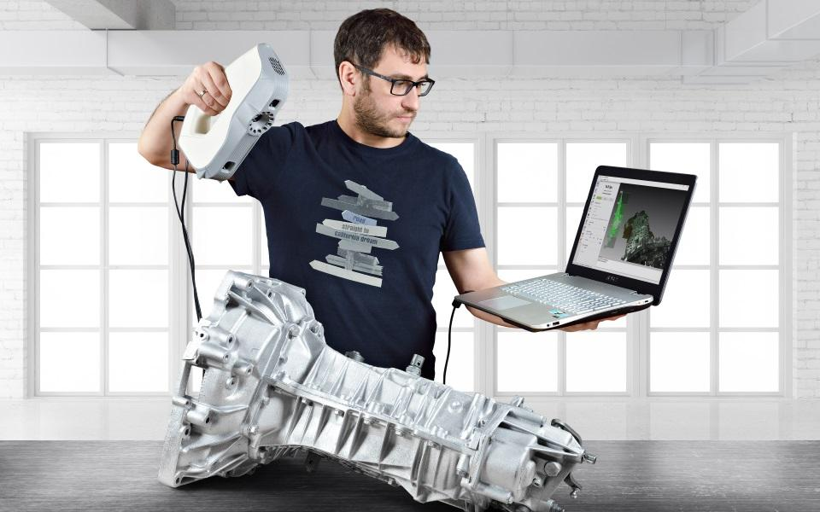

Businesses can analyze almost any equipment, part, and structure in minutes. It is possible to examine the existing products and services in order to create new designs. 3D laser scanning reverse engineering allows companies to lower their work costs and create new ideas. It is possible to invest in new products or innovations, and add new features to existing products. Many manufacturing experts suggest that people need in-depth analysis of old products before designing new ones. This will help reduce production costs and avoid wasting time. You can adopt reverse engineering technology to improve your product quality. Reverse engineering has the added benefit that it can help you find new product innovations. 3d scanning reverse engineering is a big help to companies who want to know about product generalities and ensure user safety. Reverse manufacturing can be used to inform businesses about their products and reduce the risk of product failure. This increases quality and creates loyal clients. To ensure that products are safe, businesses can use reverse engineering or 3D laser scanning.

Every company strives to save money while providing excellent quality equipment to its customers. Reverse manufacturing can increase product quality and reduce manufacturing costs. Industry experts recommend that production companies identify issues during the research phase in order to avoid legal problems. Technology engineers can now relax and let someone else handle their burden with reverse engineering. They can reach innovative production methods and build diverse ways of product design without overburdening themselves. Many reverse engineering companies are ready to assist their clients and offer them reliable services. Reverse engineering technology can be used to help small businesses, entrepreneurs, retailers, manufacturers, and production companies succeed in new ventures. You can increase production, meet the needs of your industry and save money. Reverse engineering allows you to create a CAD model. This helps businesses keep track of production. You can choose reverse engineering technology if you want to digitalise your manufacturing processes and increase production efficiency. This helps in mass production and inspires production engineers to generate new ideas.

