The Importance Of Portable Toilet Hire

Although hosting an event may seem easy, it is not the case as you must plan your event in advance. Even if you book the most prestigious and the most expensive venues, people cannot give their guests the comfort they deserve. Because of the large number of guests, venues are often unable to provide adequate restrooms for guests. This is a major issue for guests and makes them unhappy about the long waits to get clean. A lot of portable toilet businesses provide their services throughout the world. They offer luxurious toilets as well as portable toilets for rent based on the event you are planning. The biggest benefit of toilet hire is it conserves water. Experts have suggested that those who use portable toilets can save more than fifty percent of the water they use and reuse it for other reasons. If you are seeking for additional details on portable toilet hire, view the previously mentioned site.

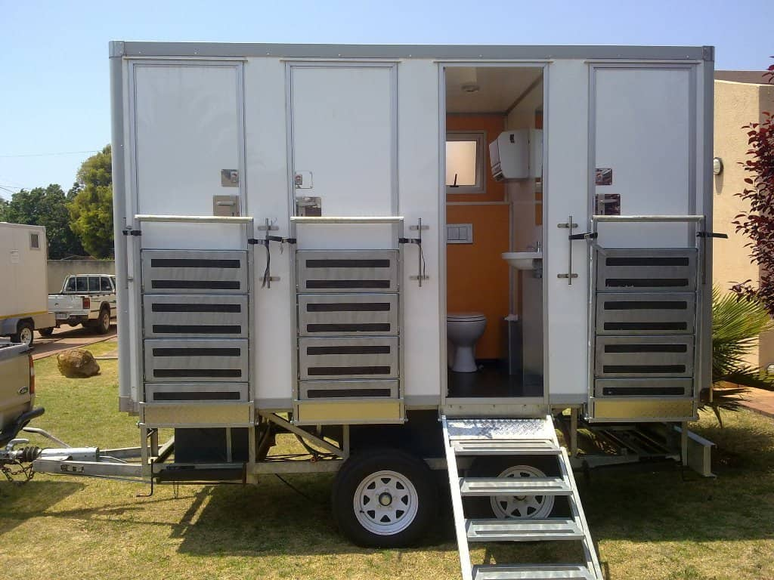

Many people have trouble making use of hotel toilets as they are often blocked or have to wait long to be able to make use of them. Luxurious toilet hire is a possibility for those who want to provide convenience to your guests while also conserving water. Portable toilets are very simple to use and do not require a lot of water. Portable toilets are a great way to dispose of waste and cut down on water usage. The portable and mobile toilets provide a convenient and clean way to dispose of garbage. Portable toilet providers often provide house-cleaning services for portable toilets. This frees the host from any obligation and lets them focus on the other elements of the event. Portable toilets are equipped with sinks to wash hands as well as a trailer that can hold the waste. They also aid in reducing the spread of disease. There is no need to worry about causing environmental harm and dirtying the surroundings. Often, venues have only one or two restrooms, which cause a load on guests.

Many attendees complain of the loos being dirty or unsanitary to use. Portable toilets solve this problem. Portable toilets are easy to use, and users don't have to worry about spreading diseases. They can be efficient in reducing the amount of insects and the spread of bacteria and pathogens. Many startups and small-scale businesses rent mobile toilets to increase employee productivity and ease of use. Portable toilets are also able to be placed on construction sites. They are then removed after construction is complete. Mobile toilets are an excellent way of improving public health and helping to prevent the spread of diseases. Many people believe that renting portable toilets are a waste of both money and time. It isn't true. A lot of mobile toilet providers can deliver toilets to you at your location. They can also modify their services to meet your needs. It allows them to tidy the surroundings and make sure that guests are happy. Mobile toilets can be hired for special occasions, like weddings, family dinners or corporate events.

