Individual Guide On Stenabolic Tablet Online

People cannot pay attention to their bodies due to their busy lives. Therefore, they require extra vitamins and mineral to help them feel more energetic. Many experts recommend supplementation to ensure that your body receives all the nutrition it requires. Taking supplements improves your body's functionality and increases your skin's glow. Supplements can not replace eating, but they are best taken along with food. If you take suggestions from your health expert and pair your diet with the best supplement, you can increase your metabolism. Many people believe that supplements are only for those involved in sports or physical work. This is false. You can take any health supplement, but you must consult your doctor. Dynamic performance supplements can be taken to improve your health and longevity. As they age, the body begins to lose its resistance and people feel tired from doing small tasks.

Supplements can help in these situations. As people age, it becomes difficult for their bodies to absorb the proper nutrients and minerals. Supplements like RAD 140 can prevent health problems and help to restore your body's nutritional levels. This supplement reduces anxiety and stress, as well as maintaining a healthy nervous system. Supplements boost cardiovascular function and aid in muscle building. This is great news for those who are health conscious and gym-goers. Combining food and vitamins can help your body combat diseases. RAD 140 pills strengthen the immune and nutritional systems. People purchase supplements from their local medicine store or supplement dealer. Many times, the products they sell are poor quality and can cause harm to your body. Many licensed online supplement suppliers offer their services. Are you looking for stenabolic? Visit the earlier mentioned site.
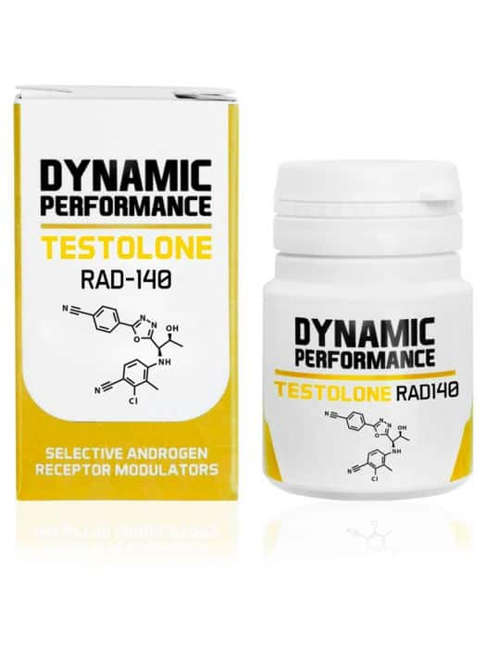
Their website lets you browse many health supplement brands so that you can choose the one most suitable to your preferences and tastes. This helps people make informed decisions and save time. Online supplement providers offer genuine products and attractive deals and discounts. Supplements such as RAD 140 help to keep your body in a good place and enable you to reach your wellness goals. Supplements can support healthy metabolism and provide energy. Combined with a healthy diet, supplements increase body efficiency and protect your body from overall ageing. Supplements can help people get the most out of their exercise routines. RAD 140 reduces body fat and increases testosterone in men. It promotes muscle mass growth and has no side effects. Supplements will not make you bulky, but they will provide you with the nutrients that your body needs. Exercise can lead to muscle pain, and a higher level of stress. This is why RAD140 should be adopted by individuals. Your body is subject to wear and tear from long-term exercise and overexercising. A supplement can aid in the healing process. It allows your body to heal by providing it with required nutrients.

