Individual Guide On Pink Pussycat Sensual

Many people believe that females are immune to libido difficulties. This is not true. There are many females who complain that they lack sexual desire due to they get older. It creates marital tension, and can put an end to their relationship. Female enhancement liquids are capable of helping. It enhances the libido of your partner. You can have a good happy relationship with your partner. This can help to build trust and build great relationships. The best thing about engagement shots for women? They can be taken by anyone before they make love. This increases the enthusiasm for you both and allows you to enjoy yourself. A lot of women have shared their experiences online with female enhancement fluids and have reported that they feel more powerful. Contrary to what many believe, female enhancement fluid is difficult to use and is packaged in bottles, it can be very simple to make use of.

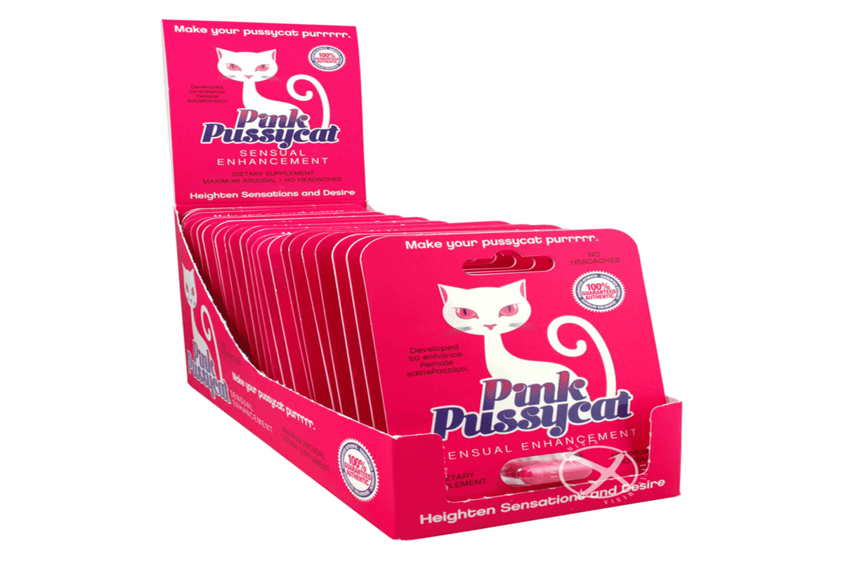

A lot of women are less sexy than they did when they were younger, which can make sex difficult. This puts a strain on their relationship, and can make their spouse unhappy. An enhancement shot for women can be taken immediately after eating to increase your sexual libido. Many couples report that enhancement liquid has helped them to grow their relationship. The greatest benefit of the enhancement liquid is that it does not cause any adverse negative effects. The body's immune system is not prone to negative reactions to the shots of enhancement. This is great news for brides and wives who feel that something is missing from their relationship. Females usually have a difficult to please their partners. This can lead to disputes and other issues. Many times, women feel an increase in their sexual desire or don't want to be loved due to emotional and/or social problems. Many women are working and career-oriented and feel they do not have the energy to please their partners after long work hours. Check out the below mentioned website, if you're looking for more information regarding the pink pussycat.

Female enhancement liquids are a way to boost their energy levels and make it easier for people to have fun with each other. Due to their physical differences the majority of couples are forced to split or go through legal separation. Women see love as a chore. This causes conflict and tension between husband and wife. Female enhancement liquids can be bought to fix this issue. If you are looking to increase your enjoyment or have lost the interest in your relationship, then you should opt for women's enhancement liquid to see the difference yourself. Enhancement liquid is often suggested to couples by psychotherapists. It is possible to still have pleasure and have fun with your relationship even if you're on an extended, sexual journey. Female enhancement liquid also increases confidence and may allow you to have an orgasm. Female enhancement liquid delivers the best results and has helped many females get their confidence back. Strong relationships and happiness is only achievable with a strong physical connection. Female enhancement liquid is available in a variety of flavors. Explore their online collection and choose the flavor you prefer.

