Facts On 5G Router

No matter what business they are, it doesn't matter what type of company they run. Companies need to be connected 24*7 to their investors and clients. Many businesses are now using a 5G WiFi router. It gives them faster data transfer speeds and improved connectivity. A 5G WiFi router's greatest benefit is its ability to be connected to multiple devices. This allows companies to build a'mini-work network'. This provides better connectivity between managers and employees, which can lead to increased productivity. Start-ups and small businesses can install a 5G WiFi router and antennae in their offices to connect all devices. It allows them to save money long term and reduce their internet costs. Click on the below mentioned site, if you're looking for more details regarding 5g router.

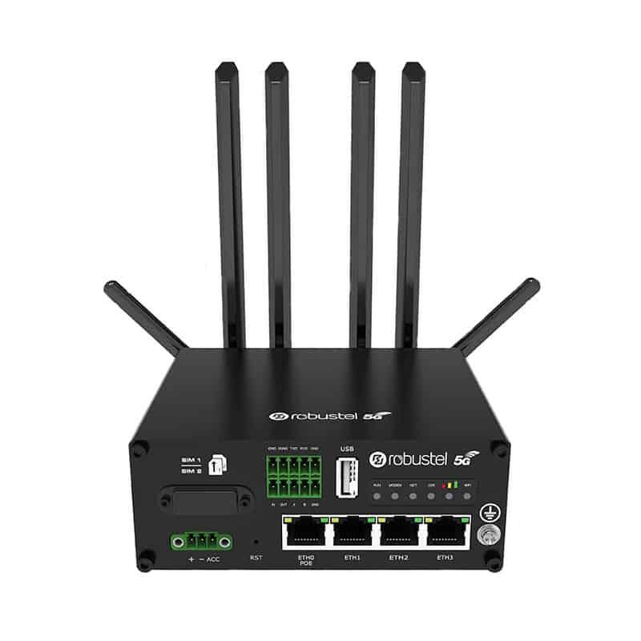

A 5G office router allows people in remote areas to have better internet connectivity. Poor connectivity is common for rural areas and those who live in the countryside. With a 5G router, businesses can operate in remote locations and ensure they can meet their clients' demands. Many experts suggest using routers with antennas to get fast connectivity. 5G routers have the added advantage of being easy on your pocket. Many companies are replacing wired broadband with 5G networks. Another benefit of 5G routers is that you can carry your router anywhere you go. 5G routers have the advantage of being portable, so they can easily be moved from one location to the next. They do not require a wired connection. There are many routers in public areas and vehicles that provide better connectivity. To provide unrestricted internet connectivity, authorities also installed 5G routers in public transport (trains, buses and ships). This is a huge help for anyone involved in groundwork and construction who need to operate in various locations. To provide Wi-Fi to their customers, many cafes also use 5G routers.

With 5G technology's advancement, anyone can buy 5G routers. This allows them to have wifi no matter where they are. Businesses often want internet access 24 hours a day, but don't want to spend a lot. They can also have a wifi-enabled workspace and appear professional with a 5G router. The biggest reason for the rising popularity of 5G routers is they are affordable. For uninterrupted internet access, users don't need to worry about how much they will cost. Many people feel that installing cable internet wires takes too much time and is too difficult. Excellent internet connectivity allows company leaders to keep an eye on their staff. This helps increase employee productivity as well as save money. A faster internet connection allows you to store work online and reduce the hassle of paperwork. There are many options for people to purchase high quality antennas, routers, and other accessories online. Online 5G router suppliers offer delivery options to your residence or office. However, make sure you choose a reliable service provider who can cater to your needs perfectly.

