Details About Best Canvas Tents

The public is more prone to go camping more than they ever have been. Camping allows families to spend quality time together, and it also brings them closer to the natural world. The most crucial aspect of camping is choosing the appropriate tent. People often select the wrong tent only to realise later that their tents do not withstand the changing conditions. This might cause a dreadful impact on your mood and put your loved one's life in danger. Hence, people need to choose the right camping tent. Canvas tents are among the most popular tents. For campers who are looking to go hiking or camping canvas tents are an excellent option. Canvas tents are robust and constructed from durable fabric. They also allow for easy ventilation. Many campers feel uncomfortable due to the humidity levels in their tents.

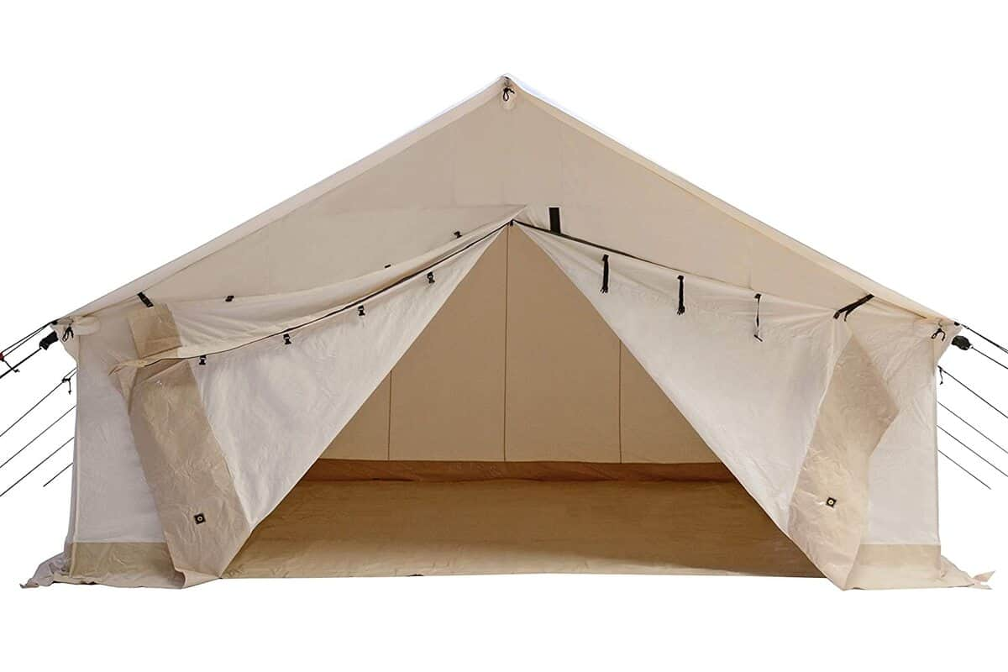

The tent's canvas fabric regulates temperature, and allows the moisture that has been cooked to escape through the fabric of the tent. This helps to keep the tent cool, and also allows you to relax. Canvas tents are water-proof, which is an benefit. Because canvas tents are constructed of high quality they are protected from rain, sleet and snow. It is not necessary to worry about the ever-changing weather conditions. Although plastic tents may seem as a good option for saving money but they can cause issues in the future. Tents made of plastic aren't waterproof and can become wet. They do not hold water and are therefore not damp. Canvas tents are recommended by a variety of camping experts due to their ability to breathe. Canvas tents are more comfortable and let you breathe more easily. Canvas tents let moisture to escape and decrease the amount of moisture. Browse the below mentioned site, if you are hunting for more details about canvas bell tent.

Canvas tents are more durable. Tent sellers on the internet offer canvas tents that are made of tough, tear-resistant fabric. This saves campers money since they do not have the burden of having their tents replaced every so often. In the case of bad weather and strong wind, branches of trees fall on tents which causes many damages. Canvas tents can be used in extreme weather conditions because they are durable. Another benefit of buying canvas tents is they allow ventilation and are strong. Canvas tents made of bulky cotton are able to withstand extreme climate conditions. Canvas tents have a long history and were utilized in military training camps. With time, they have become an essential camping accessory for the campers. There are several types of tents made of canvas available in the market. You can purchase the one which suits your needs and requirements. There are numerous certified tent companies that offer their services online. You can choose from a variety of tent styles.

