A Few Details About Dynamic Performance MK 677

Performance is the most important thing for any sportsperson. They take every measure possible to improve their sports performance. Sports supplements are an excellent way to improve performance. Many athletes use them for their daily intake of vitamins, minerals, proteins, and carbohydrates. Supplements can help with many injuries and improve performance. Supplements are not made from chemicals or other related substances. These supplements are typically made from herbal herbs or other medicinal plants. Laxogenin is an integral compound widely used in different supplements. Laxogenin comes from plants and is used to manufacture sports and other health supplements.

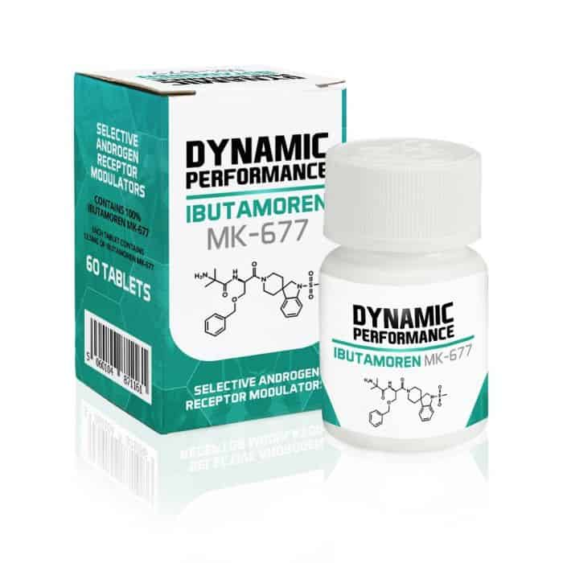

It is a powerful way to improve muscle strength. Different sports stars use it. But, it is not directly administered and can be consumed in pills, powder, capsules and tablets. Over time, the individuals receive extensive benefits from consuming sports supplements. It offers convenience in dietary matters. The supplement can be used as a source of many nutrients. Athletes don't have to take individual vitamins and mineral supplements. It is an individual serving of whole food.Supplements for sports are designed with healthy nutrients. Therefore, the body's health factor is high and easily digested and absorbed. Some research suggests that supplements for sports are easier to digest than foods cooked. It is crucial to perform protein synthesis immediately after a workout. Because of their high-quality protein and other nutrients, the best way to stimulate protein synthesis is to consume sports supplements. Are you searching about mk 677 buy? Visit the previously discussed site.

The nutrients are directly absorbed by the bloodstream, increasing muscle strength.Laxogenin, a necessary ingredient in supplements for athletes, is available. An authorized dealer can offer laxogenin products to individuals. You can also look online to find the best supplier of trusted sports supplements. Sports supplements can also address dietary issues, thus allowing athletes to get more power and ultimately enhance their performance. It is vital that you only consume the appropriate amount of supplements. The nutritionist will usually give sportspeople a comprehensive diet plan that details the body's requirements. However, it is a good idea to get your doctor's prescription. Some steroids could be dangerous for your career. Side effects may result from excessive consumption. It is recommended that you consume the right amount at regular intervals. Consumption generally depends on factors like health, body, exercise routine, sports played, and more. Laxogenin can be an essential component, as I have said. Excessive consumption can have severe side effects. Start with a low dose and increase your intake as recommended by your doctor. This will make it work wonders and improve the overall sporting performance.

