The Importance Of Orthodontic Clinic

People today are often plagued by tooth pain and other problems. Professional dental clinics have sprung up all over the country to provide their services. Online appointment can be booked with a dentist that suits your schedule. You will get a professional diagnosis. After taking an orthodontic treatment, you will notice a visible improvement in your teeth appearance. People can feel self-conscious when they have crooked or misaligned smiles. Misaligned teeth can also cause pain in the mouth when they chew their food. Misalignment of teeth also causes digestion problems. Orthodontic therapy can help people feel better about themselves, improve their oral health, and make them feel more confident. Too often, people don't seek orthodontic treatment in time. They regret it later. People can get treatment quickly if they are diagnosed early enough. Oral hygiene is another benefit of choosing orthodontic services.

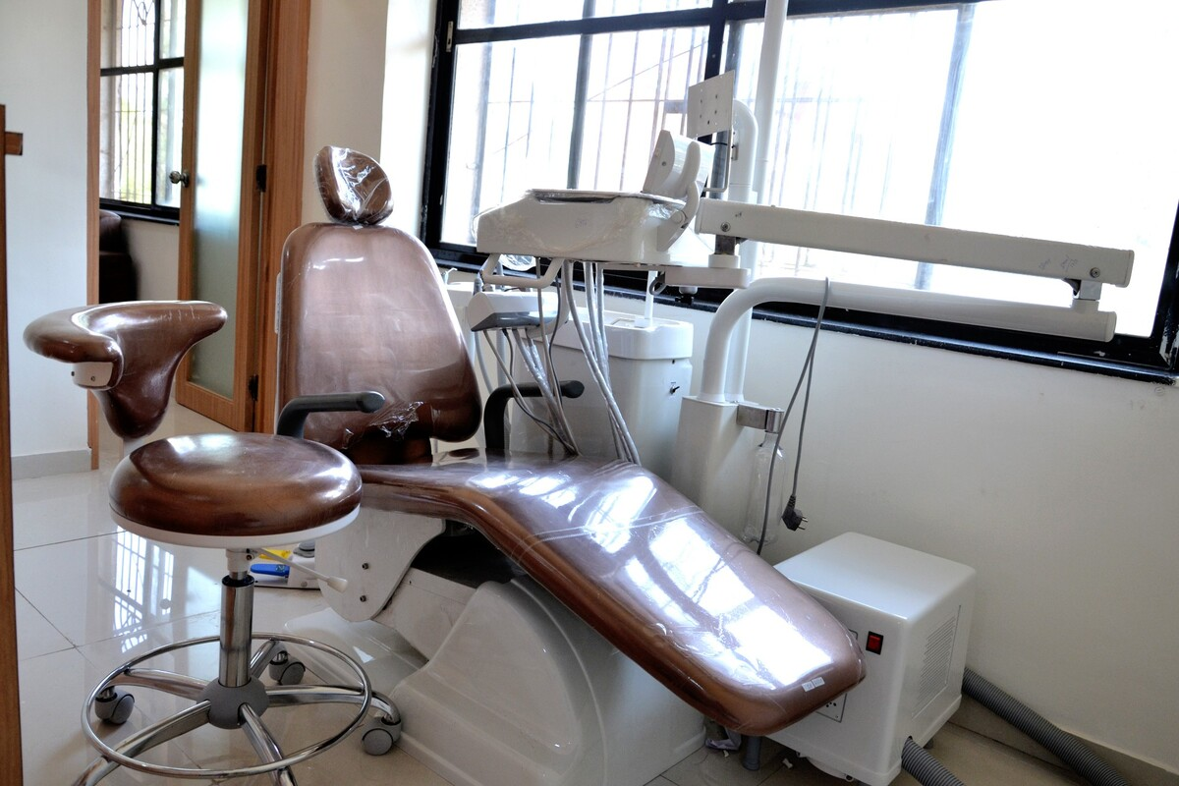

Because of crooked or misaligned teeth, many people have trouble brushing their teeth and flossing. A braces treatment can help. If you choose to straighten your teeth, you can effectively take care of the health of your mouth. Misaligned and misaligned Teeth are often the root cause or all of our health problems. Unfortunately, many people are unaware of this. Professional dental clinics often offer simple payment options for their patients. People can pay a certain amount after treatment is complete. This reduces the financial burden and helps people get quality teeth care. It is important to choose a dental clinic that offers orthodontic services. Many people find out that their dentists are not efficient after they have made the final payment. This is why you need to know about the dental clinic's team, dentists' qualifications, and the equipment they use. This allows people to make informed decisions and obtain professional oral health care. Visit the below mentioned site, if you are searching for additional information about orthodontic clinic kensington.

Many dental clinics have websites and oral health care blogs. You can visit their site and learn more about their services and past work. You can also book an appointment online. This site is great for busy people who need immediate treatment. Before selecting an orthodontic clinic, people need to know if they are equipped to deal with emergencies. Professional dental clinics use the latest technology and work to provide immediate relief to their clients. Another benefit of opting for orthodontic treatment is it improves oral health and keeps your teeth healthy. Orthodontic treatment is a way to improve the function of your jaws. People often complain of jaw pain as they have crooked teeth and want to chew their food correctly but cannot do so. When your teeth have been straightened, you won't experience any difficulties chewing. This preserves the jaw's original position and improves digestion.

