Important Things About Sound And Lighting Hire

A stage rental company can provide a large stage for your event. Many companies offering indoor and outdoor stage hire are well-equipped. This will allow you to run your event smoothly. It is crucial to hire the right stage company for your event. Reliable stage rental companies offer a wide range of outdoor stages in all sizes and shapes. As they have been providing stages for many years, they are well-versed. You can easily find an outstanding stage to fit your needs within your budget. They can help with all your creative ideas, such as when you are choosing an outdoor stage. Many stage hire companies can provide outdoor stages that match your event theme. If you are searching for more information on lighting for weddings, browse the previously mentioned site.

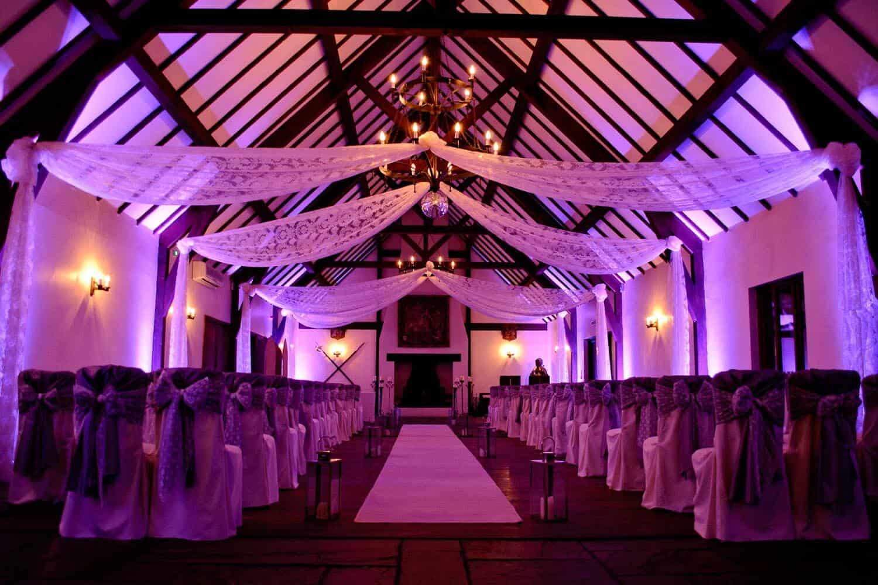

They are efficient in handling all the requirements so that you can be at peace and focus on other arrangements for the event. These companies strive to ensure customer satisfaction. These companies can help you get the stage and audio visual solutions that are essential to a successful event. Professional stage hiring companies ensure that everything is synchronized so that it runs smoothly. Their goal is to make your event a huge success. It is better to rent the outdoor stage if you only plan to use it for one event. Renting is more affordable than buying. You have flexibility, and there are many reasons why renting is a better option than buying.

You can just return to the outdoor stage once the event is over. It is not necessary to rent additional space. A rental stage can also offer you a wide range of options. Many stage rental companies stock a variety of outdoor stage options that can be used to host your event. Renting will also help you save money on stage costs, especially if it is only for a limited time. Hire a stage has many benefits, including the fact that it is possible and convenient. Hire a stage company will send technicians and operators to the venue to help you set up the stage. You can focus on other aspects of your event and leave the technical stuff to them. In short, stage rental companies are complete professionals and help you produce the best results. You want a reliable company that will meet your every need and make your event unforgettable.

