Floral Event Designer - What Every Individual Should Look At

Hosting successful events requires a lot of effort, time and effort. People love to have floral arrangements at their functions but feel they lack the skills and knowledge to make floral arrangements by themselves. Professional florists are the answer. They offer their services to people at affordable prices and assist them by designing bespoke floral arrangements for parties and weddings. Flowers can lift your mood and impress everyone. Professional florists can help make your event the talk of town. Many companies also take the assistance of professional florists to make their event look professional and formal. This makes it easy for them to leave a lasting impression on potential investors, company leaders and clients. Certified florists offer a wide variety of services. Check out the following site, if you are seeking for additional information regarding bespoke floral event designer.

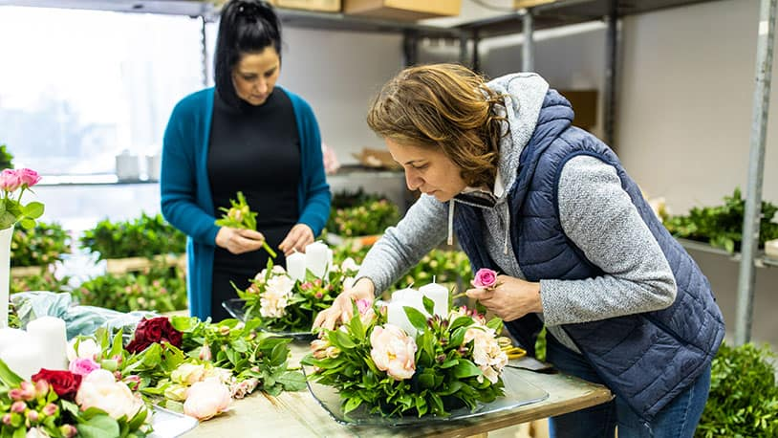

This is why people are increasingly hiring them. An event florist will arrange beautiful banquets made of exotic flowers for you. Florists are creative and have the experience to assist their clients in the most efficient way. They can arrange flowers for each table or make arrangements on the walls. Certified floral companies will meet with clients to discuss their requirements and their vision, before determining a budget. You can let them know how much you are willing and able to pay for the floral arrangement. Florists love to create original designs and mix authentic and modern styles. To ensure that the floral arrangement matches the event, brides can discuss the colour scheme and style of their wedding and reception. A professional florist will ensure the flowers blend with the rest of the decorations and do not look out of place. Employing florists can reduce stress for their clients. Florists are often too busy with other arrangements, so they don't buy flowers until the end.

Sometimes, people lack the skills and creativity to arrange flowers to make beautiful floral arrangements. A lot of people assume they can arrange flowers by following a DIY floral tutorial. However, this is often not the case. It is crucial to hire professional florists to help you reduce stress, arrange and organize everything quickly. If you feel overwhelmed by all the preparations for an event and don't know which flowers to pick, a certified florist may be able to help. They are experts in all flower types, and can help choose the best flowers for you. The florists will arrange floral arrangements and provide banquets prior to the party. This allows guests to spend their time arranging other party decorations. A floral arrangement service can be hired to provide a range of flowers. People can select from several flower varieties and get high-quality flowers for their weddings, receptions, birthday parties and corporate events.

