An Overview Of Video Production Company

Video production companies provide high-quality, audio-visual content that is both professional and affordable to businesses. A video production company produces audio-visual content for many businesses. The marketing strategy of the firm's audio-visual content is a key component. Typically, the video content comprises commercials, online ads, product showcases, and much more. Additionally, the video production entities also offer corporate videos and employee training videos. Many people think that both film production and video production entities are the same. They are however, distinct from each other and play different roles. There is a big difference between film production companies and video production firms. It's because movie production entities usually produce TV shows and movies. Are you looking for video production company london? Check out the before discussed site.

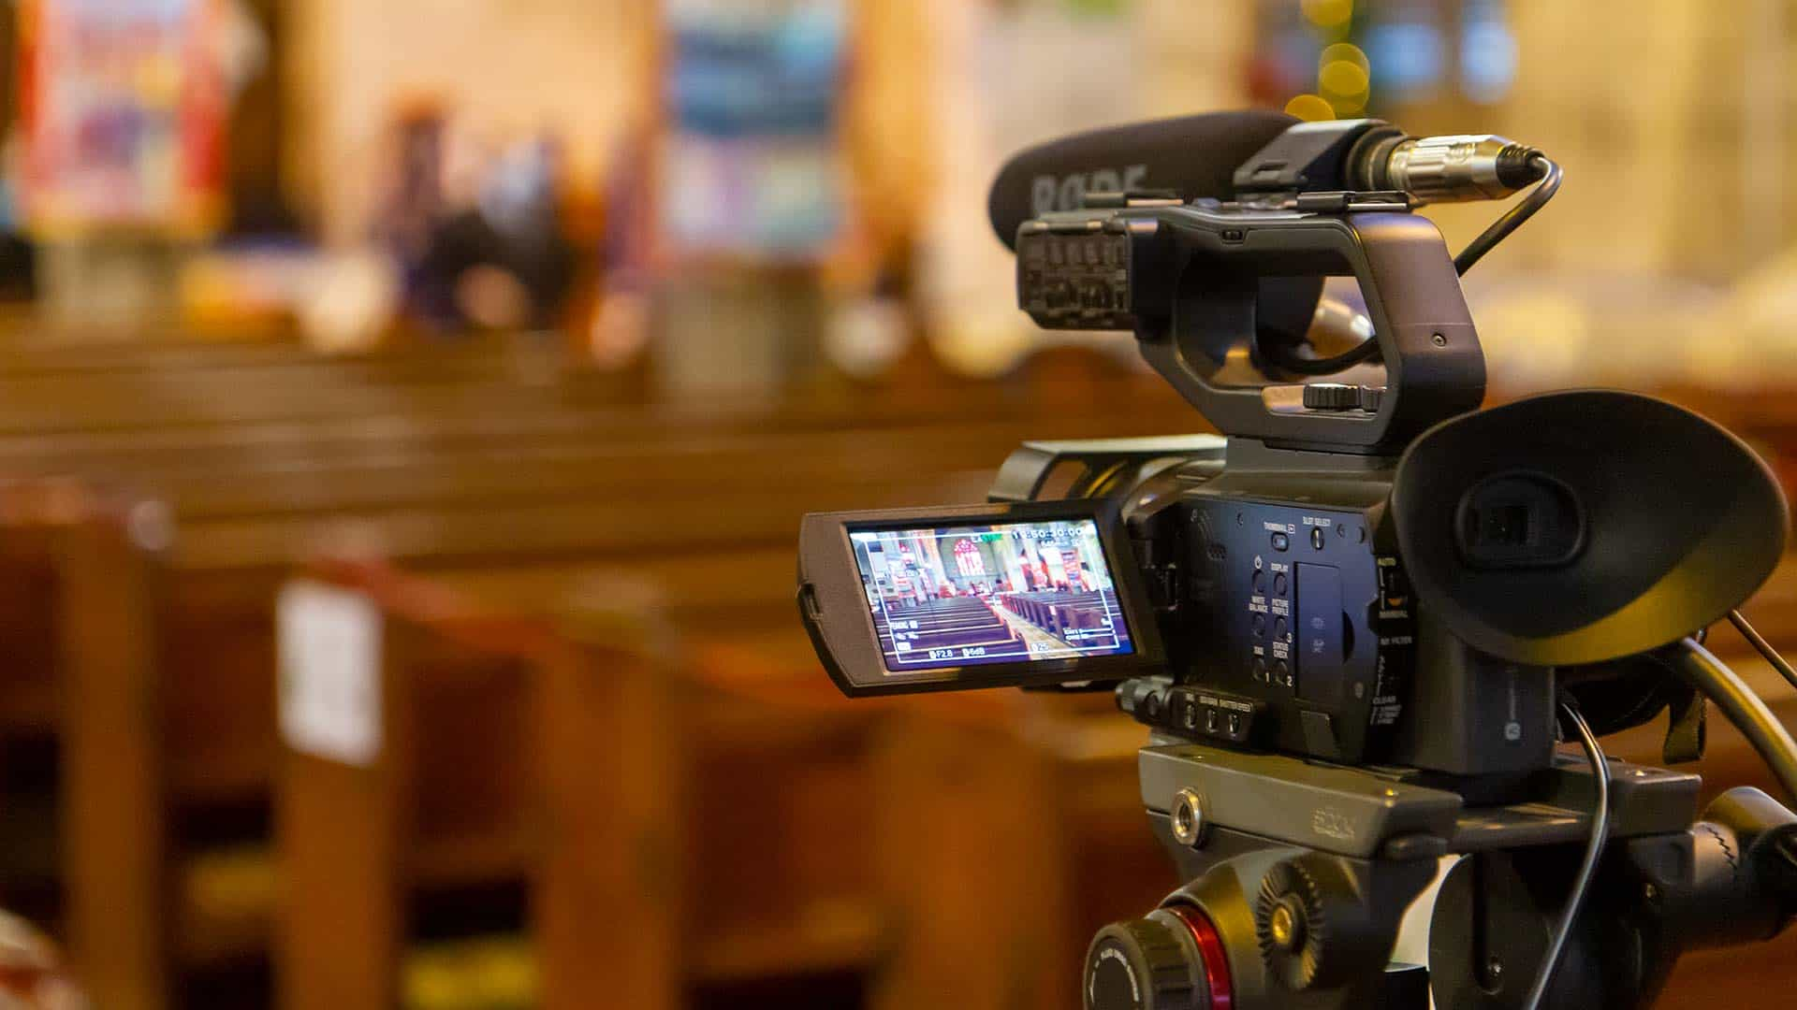

Video production agencies, on the other hand, produce content primarily for commercial and marketing purposes. They play an important role in overall marketing strategies. There is also a difference between a videographer, and a production company. They both are entirely different and hence perform numerous roles. Videographers work mostly on weddings, parties and other live events. The videographer also works behind the scenes and cannot be seen on the stage. The videographers capture the action on the stage. They tend to be away from the stage and aren't involved in much. Video production agencies, however, are more involved in the whole event. Additionally, the agency includes highly skilled and creative staff members who specialize on different types of creative videography. They are also proficient in editing and planning, making them superior and more skilled.

The job of a video production agency might seem straightforward to the layman. However, imaginative thinking is required. In fact, routine tasks are more complicated than an individual can think. A video production company creates and edits films for multiple businesses. Video production agencies work closely with clients to meet their specific needs. Additionally, the firms conduct market research to give customers the best and most original visual content. The firm handles everything, from the pre-production right through to the final touch. In summary, it is important to note that contacting video production agencies is the best decision business entities can make. The video production agencies are well-equipped and have the creative skills that will help them provide unique content. When selecting a video production agency, the individuals or the business firms must consider their past work, experience, and creativity. These companies enhance the market and produce a better, more qualitative audience.

