A Summary Of Unique Wedding Entertainment

Entertainment is the heart and soul of every event. The general entertainment keeps the guests busy and sets a tone for the event. With the right entertainment, events become more interesting. Whatever the event's theme, the entertainment that makes people happy and relaxed will remove any boredom. When planning an event, people should also think about what entertainment is best. Entertainment is often seen as an expensive aspect of planning events. However, contrary to this thought, it is imperative to look for affordable entertainment options. Every event needs entertainment. Visit the following site, if you are seeking for more details on unique wedding entertainment.

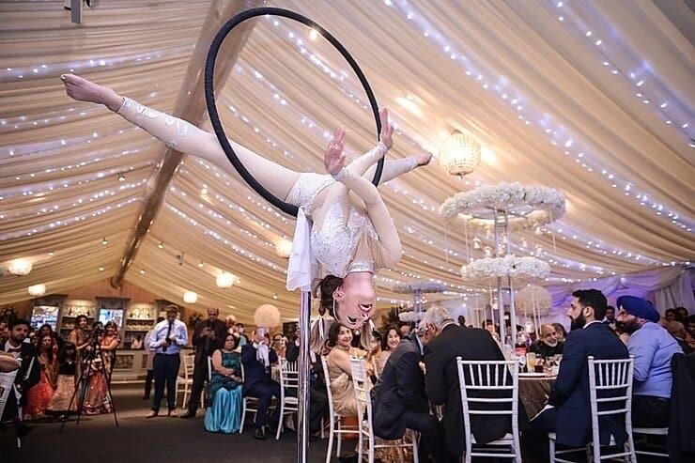

To make an event memorable, successful, and enjoyable, you should hire the best entertainment professionals and get keynotes. The right entertainment stirs hype among the audience significantly. Some people will not be interested and cancel their plans to attend the event. Although they might be interested in the entertainment provided, such people may decide to visit if they hear live music or fire performers. People are encouraged to go to the event for the best entertainment. High-end entertainment has become the norm. People expect more from entertainment, with so many events and parties happening around the corner. Individuals are now looking for entertainment at any event, whether it's a corporate event or a birthday party. Guests who aren't entertained often lose interest and go home sooner if they don't feel engaged. Gone are the days when only music was the source of significant entertainment for guests.

People expect more, and are looking for entertainment that will keep them busy and entertained. Individuals must plan the entertainment to create a central point for the guests present. A wedding without music is unlikely to draw people. However, hiring fire performers to dance to music will certainly grab everyone's attention. The guests may roam from one place to other in the venue. However, it is imperative to give them an eye-catching element in the event. It is important to mention that entertainment can add an extra wow factor to your event. This is a great way of keeping people focused on one place. Therefore, it is fitting to mention that planning entertainment for an event is not easy. It is daunting, and it is best to hire entertainment services. With their help, individuals can find the best entertainment to entertain their guests. Furthermore, the agencies work closely with the client and provide unique entertainment as per the budget. The internet allows individuals to quickly find the best entertainment agencies and select the most suitable one for them.

