A Glimpse At Event Venue Hire

Hosting an event can give people a break in their daily routines and allow them to socialize with their friends. It isn't as simple as it sounds to host and plan an event. This is why many people hire event venue rentals. It is easy to find the perfect venue. Many venue rentals will work with you to understand your needs and budget. Ask them for help and they can assist you in hiring indoor or outdoor spaces to host your event. People's busy schedules are the largest reason for increasing demand for venue hiring. Working professionals are often overwhelmed by their work schedules and don't have the ability to maintain their homes. If you are looking for additional details on event venue hire, browse the previously mentioned website.

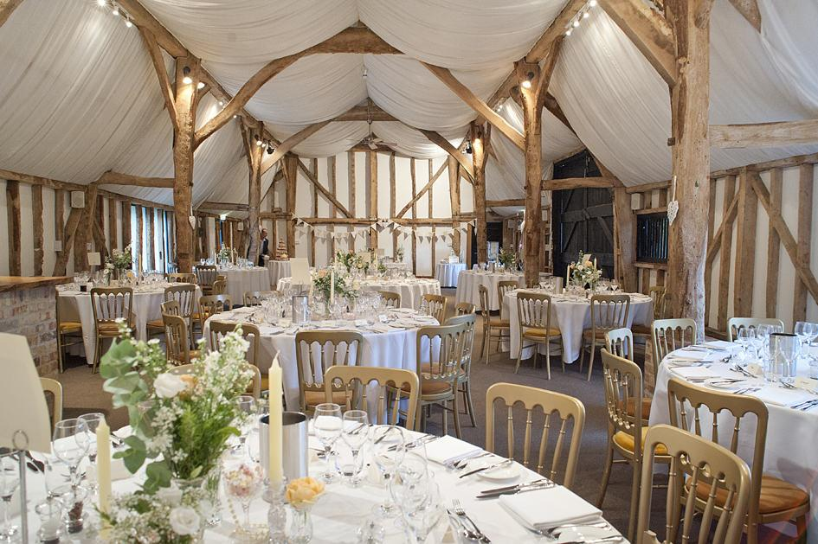

This is why you should consider renting venue spaces. You also don't need to worry about making your guests uncomfortable. Many people feel they are only allowed to hire venues and sporting clubs for weddings. This is not true. Many clubs offer rooms for family get-togethers, corporate functions and meetings. Fully furnished venues can be rented to make sure that the guests have a wonderful experience. A popular venue increases excitement for your guests. It also ensures that they attend the event with their family. Many companies also hire venues to host corporate events, meetings, and presentations. The best way to impress clients is to hire event venues. It is possible to hire a venue for a meeting with clients or foreign delegate. Event venues are comfortable for guests and provide sufficient space.

This makes it possible for your guests to meet and socialize, which can be a great help for those with claustrophobia. You cannot host a party if your apartment is rented. A rented apartment is generally limited in space and this can be a problem if you have many people coming to attend your party. People often host a party in their homes, and their guests have to stand because of the lack of sitting arrangements. Your guests' comfort should be your first priority. This is why it is best to select a multi-purpose hall which has ample space. This ensures your guests are not disappointed with the arrangements and do not have to stand the entire event. Many clubs provide great venues to their clients. Each of their rooms is fully furnished and decorated. Whatever event type you have, you can provide your guests an exceptional dining experience.

