User Guide On Industrial 3G Router

The internet has become an indispensable part of our everyday lives. The internet's overall speed is what matters most to people. Therefore, everyone prefers fast internet. 4G technology was invented to remove slow internet speeds. 4G has a faster speed than 3G but is still significantly slower than 3G. 4G LTE, which is also known and very popular, is also well-known. 4G Long Term Evolution stands for high-speed data downloads. Many homes, businesses, schools, offices and other places can get high-speed internet through 4G wifi routers. An individual can connect multiple devices to the router. Check out the below mentioned site, if you're looking for more information regarding industrial 3g router.

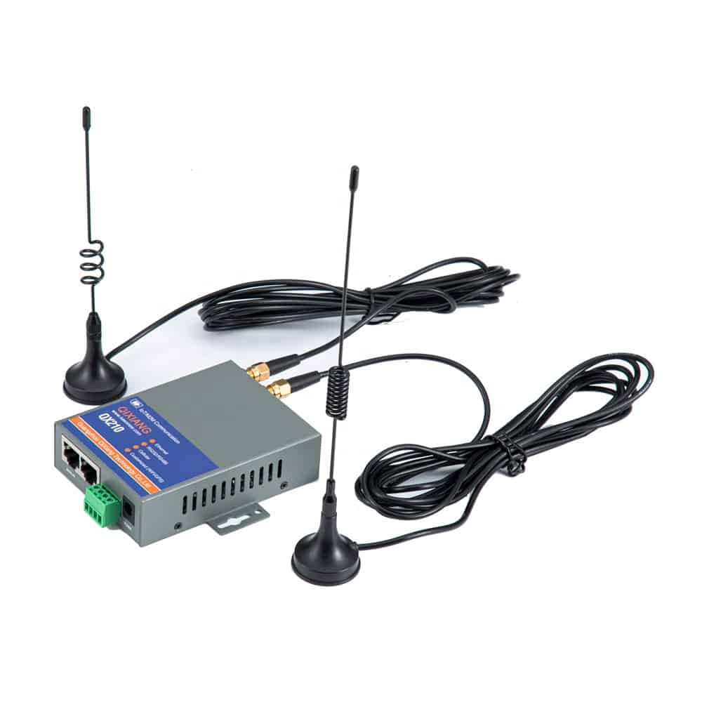

These include mobile phones, tablets and modern televisions. The 4G LTE WiFi router has many advantages. The connection is available to all devices. This connection can be used by non-wired devices as well as wired appliances such as printers. You will get the best internet connection if your device is within the router's radius. For rural areas, or areas that have had poor internet connectivity in the past, a 4G LTE wifi router will be a great choice. This means that areas that used to be without internet access can now enjoy a stable internet connection. Other than this, a wireless 4G wifi router is also great for places where wired broadband cannot be established. Individuals can also set up 4G antennas to enhance their internet connection. For setting up a 4G wireless wifi router, it is advised to call an expert. Experts can help you establish a network connection.

A 4G wifi router can be used to establish temporary internet access in places where wired or layered broadband is not possible. Other than this, such a network connection is perfect for the places where a connection is needed for a short time. For instance, such internet connections can generally be witnessed in trade shows or exhibitions, where an internet connection is required in order to demonstrate items to people. In public transport, there is a wireless router that allows users to check their email while they are travelling. The 4G wireless router can reduce downtime for businesses. A 4G wifi network router has a better response time than a standard 3G router. It provides strong internet connections and enhances the overall user experience. Individuals must set up a 4G router in order to establish a strong internet connection. Numerous entities offer these services and have the best 4G wifi routers. They provide the best internet speed, experience, and connection.

