Freelance Film Colourist - An Introduction

Videos can allow you to reach out to people and convey your message. Videos are often able to inspire people and help them make important choices. Many companies offer video content to help users connect with one another. Effects are a crucial aspect of video content. People need to hire color grading firms to ensure that their videos are memorable. It improves viewer's experience. The technical aspects of colour grading are often overlooked by people. Grading colours isn't something you can do in a matter of hours. It requires expertise. This is why professionals are becoming more popular in color grade.If you're looking to learn to create an impressive video but have no ideas about the colour filters, you need to take the assistance of professionals. Lack of imagination in videos can cause companies to fail in social media. It is not enough to create videos for business. It is essential to add effects to make them more compelling.

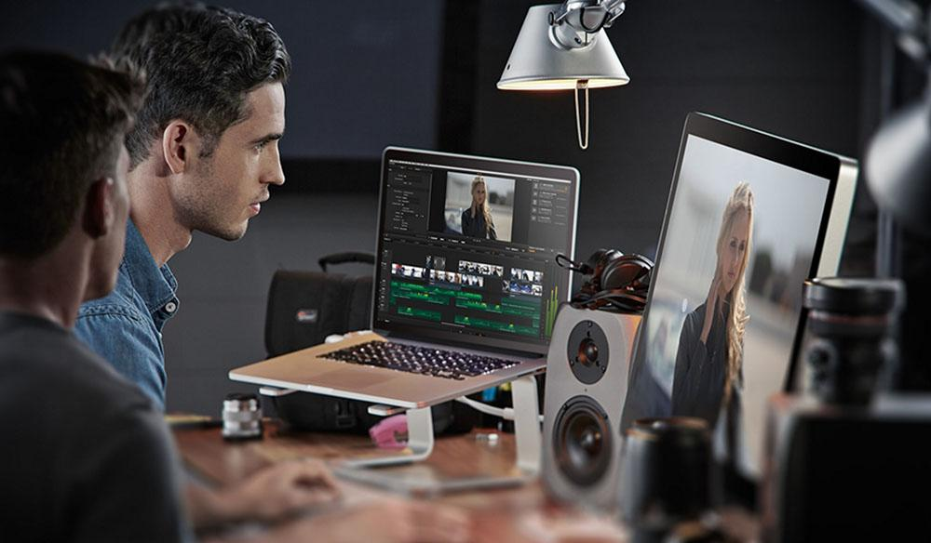

A bit of colour and lighting can create a captivating video. People need to know about the video aspects that induce users' interests. Numerous factors affect the success or failure of the video. These include contrast, temperature and saturation.Then, the individuals combine the clips together to create a complete project. To ensure that your video meets viewers' expectations, it is important to hire skilled colour graders prior to completing your project. They have the expertise and experience to help clients as well as to determine the best elements to include in videos. They make use of the most modern equipment, such as color palettes, analogous palettes, complementary palettes as well as monochromatic and monochromatic palettes. They are always happy to help their clients and get to know their needs and budget prior to tailoring their services to meet the user's needs. Go to the below mentioned website, if you are searching for more details regarding film colourist london.

Merely adding colour filters to videos does not make them compelling. You need to know about the technical aspects of your project and then tell your tale in front of the world. The color grading company alters the mood and emotions in your videos, making them more engaging. This makes the videos more enjoyable for the viewers. Professional colour correctors enhance the quality of your videos, making them projects successful.The people can reach out to the colour correction services to enhance each shot frame. They are more knowledgeable about the skin tones that you are are, and can make your images appear appealing. Professional colour graders understand the needs of the client and create aesthetic effects that impact the audience. This improves the odds of success, and you can beat the competitors easily. Videos are an investment businesses make to educate their viewers. It's a good idea to use a colour correction tool to assist you in creating videos.

