Detailed Look On Wedding Lighting For Hire

An ordinary wedding can become a memorable one with the help of good decor. Lighting plays an important part in marriage. It is best to use it at night. The venue becomes more beautiful when a proper lighting setup is used. This makes the entire wedding look more romantic and creates a positive atmosphere. There are many lighting options that can be used to enhance a theme. Technology has advanced dramatically over the years, which is evident in the lighting industry. Numerous options are now available to help you choose the right lighting for your wedding. Edison bulbs are gaining immense popularity among people. These bulbs can be hung from the ceiling to add a pleasing effect to your tables or the background. If you're looking for additional info on wedding lighting for hire, explore the above site.

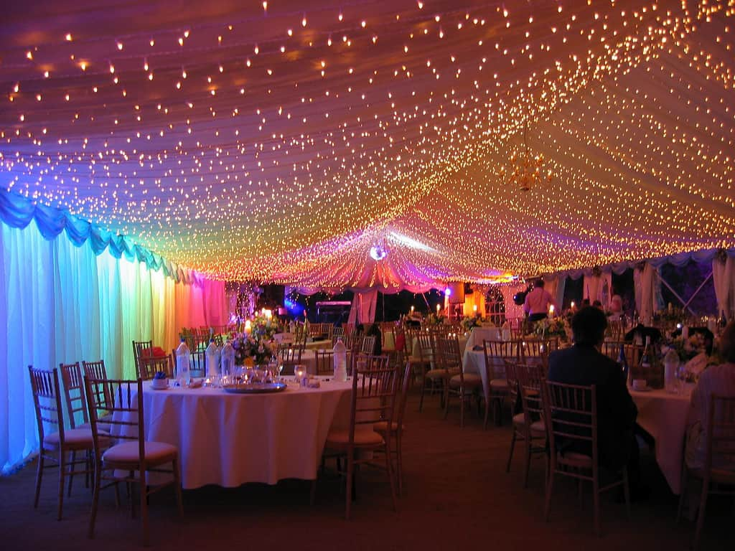

These lights can also work well on floral decorations. The lightbulb-sized bulbs create a dramatic effect in any venue and illuminate each corner perfectly. These lights create depth and dimension. The most crucial benefit of Edison bulbs is they can be hung from any height. Therefore, the individuals can use these lights as per their interests. Illuminating the backdrop is essential to keep the ambience alive. Light string curtains are a popular choice because they can be simple but elegant when done correctly. These lights come in many styles, so people can choose one according to their location and theme. For dance floors, chandeliers are recommended. They are an ideal way to concentrate on one area. They provide enough light for every corner of the space. In other words, a glam effect is added to the whole event. Chandeliers offer great lighting because they can be adjusted at different angles.

A wedding is a memorable day for the bride, and the groom. Every aspect of the marriage must be special and captivating. Tea lights are a popular choice to make the day unforgettable. Glass orbs can be used in conjunction with tea lights. They are like floating candles that appear in mid-air. These are a great choice for weddings that take place outdoors. These flowers look stunning in a green floral setting. In summary, choosing the right lighting is essential for your wedding. Multiple options are available on the internet and in the market, making it easy for people to be confused. Because they are experts in lighting, professional companies can assist individuals. You can also get help choosing the right lighting for your special occasion.

