A Peek At Signwriting Design Vehicle

Signwriting for vehicles is an important form of advertising. It enhances a company's overall branding. The majority of people see multiple vehicles with contact information. Vehicle signage is all about bringing awareness among people on a large scale. A comprehensive advertising strategy that includes vehicle signwriting and business upgrades is a great way to attract more clients. In other words, vehicle signage is indeed an excellent method of promotion. It is not only a great way to advertise, but it also offers many benefits for business entities. If you are hunting for more information on signwriting design vehicle, look at the above website.

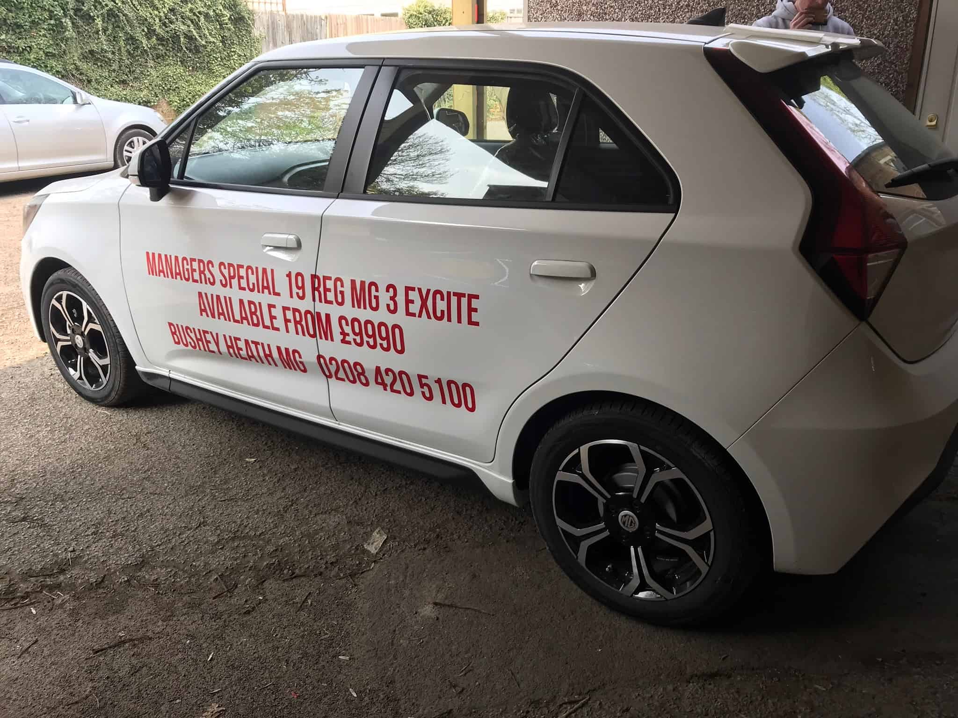

An effective branding strategy is vital for any business. Each business has a team consisting of strategists who create new ideas to appeal to more people and clients. A business typically spends thousands of dollars on social media, traditional medium sponsorships, as well as internet advertising. These methods, however, are not permanent and will not last for long. On the other hand, vehicle signage is a sure method to cater to the audience's attention for a long time. Vehicle signage is a great way to build brand awareness. Vehicle signwriting ensures long term benefits as the people do not forget the brand. Every company that owns a commercial vehicle should support vehicle signage. It is an excellent form of advertising. Enterprises can also use vehicle signwriting to express their creativity when choosing signs for their vehicles. It is more reliable, accurate, and believable than traditional advertising and promotions. Businesses can gain more clients by focusing their efforts on vehicle signage.

Signing up for your vehicle is an effective way to cut down on expenses. The benefits of vehicle signage can be enjoyed for many years, both in quality and quantity. The daily impressions of the business entity improve dramatically, and so does the attention. Every business concern can benefit from vehicle signwriting, irrespective of its size and nature. The complete trust and reliability increase as the clients trust your brands' credentials. The company presentation increases considerably, leaving a positive impression on the audience. In summary, vehicle signage can bring numerous benefits to an organisation. For getting the best benefits, it is suggested to visit a professional vehicle signage corporation. These experienced companies are highly qualified and have a lot of experience giving signage services. In addition, they are skilled in various techniques and strategies to address customer attention. The market is loaded with multiple vehicle signwriting agencies, and thus, it is essential to look for experts while thinking of vehicle signage. Individuals can seek recommendations and search the internet for the best vehicle signwriting agency.

