Thorough Study On The Voice Over Agencies

Voice-over artists are an essential requirement for many businesses. Voice-over artists are experts in many languages and have strong control. These artists are highly talented and possess multiple skills like voice modulation. Voice-over agents are often employed by businesses for their marketing videos. A voice-over artist can help make your marketing videos more convincing and effective. It's clear that voice agents can add creativity to your business campaigns. Professional voice-over agents are recommended to get the best service. Voice-over agents have great communication skills with customers. Furthermore, the agents also have relevant voice skills that are highly commendable. A professional voice-over artist is a person who receives the highest professionalism. Expert voice-over artists are a great choice.

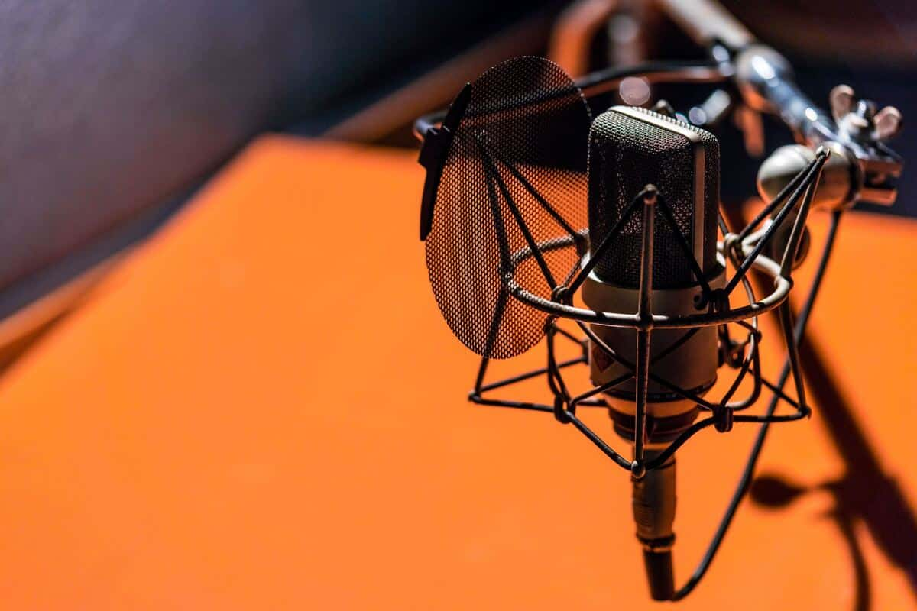

The brand's message is quickly communicated to the public by the artists. Thus, the marketing campaign creates a long-lasting and positive impression on people. Voice-over artists are preferred by many business entities for branding campaigns. It's a great idea and has many benefits. By hiring professional voice-over talent, business entities can have their marketing videos sound authentic and reliable. Businesses must establish trust among the public. A voice-over artist can be a creative way of building trust with potential customers and clients. A corporate video needs an authoritative voice that conveys their message clearly. Hiring a voice-over artist will give authority by his voice is a good idea. A voice-over agent can bring flexibility and talent to the entire team. Contacting a professional voice-over agency is important when you're looking for voice-over professionals. Are you hunting for voice over london? View the before described site.

They have a large pool of talented voice-over artists. They can also find the artist that best suits you and your requirements. Each marketing or campaign video requires different artists based on the theme. So, the company can hire different artists to add their voice to the video. They are talented, confident, and creative. Professional voice-over talent is the key to creating an impactful campaign. You get authenticity from voice-over artists. Because of the lack of time, current business dynamics require that every service be provided quickly and efficiently. Employing voice-over agent can help business save both time and money. Choose a trusted voice over agency to ensure you get the best voice over talent and complete the project on the deadline. Therefore, in a nutshell, it is fitting to mention that it is best to hire a professional voice-over artist for all your advertisement and marketing projects.

