The Importance Of Health Wellness Holiday

Many women have difficulty losing weight due to busy schedules and lack of self-care. There are many weight loss centers that offer programs and exercises to help women lose weight. They offer effective weight loss techniques that won't cause any harm to the body. To achieve long-term weight loss, you can enroll in a retreat. You'll be able to see the results for yourself. Women are often too busy with their families to make weight loss possible. If you are looking to improve your mental and physical health and take some time for yourself, a weight loss retreat can be a great option. To improve your mental health, you can enroll in a weight-loss boot camp and receive support from other women who are going through the same thing. Women who are looking to lose weight and support their families will find it helpful to join weight loss retreats.

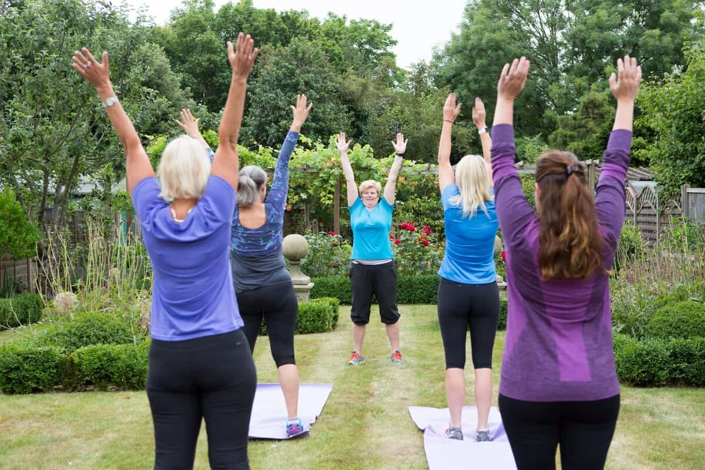

Another benefit of joining health retreats is they cater to long term fitness and do not focus on losing weight instantly. Many people don't realize that weight loss in a short time frame can lead to mineral deficiency, and eventually organ damage. If clients want to lose weight and get in shape, many health professionals recommend that they go on weight loss retreats. The retreats are not meant to be a rigorous workout or heavy dieting. Their team is well-trained and can help clients understand their needs and make effective weight loss recommendations. Their trainers don't overpressurize clients or place additional stress on their clients to get in shape. Individuals who enroll in a wellness retreat are more likely to be successful and have the confidence needed to overcome any obstacles in their lives. Go to the following site, if you are searching for additional information concerning health wellness holiday.

Health retreats offer long term fitness solutions and do not focus on instant weight loss. Their team can provide food that is healthy and nutritious, as well as education. You will be able to get advice about your health problems, and you can also receive support to help you perform at your best. These body retreats help people to make lifestyle changes that will lead to weight loss. A health retreat is also becoming increasingly popular because it offers workouts that aid muscle toning. Many women are unable to concentrate on their health due either to a lack of physical exercise or a busy schedule. Weight loss retreats help clients to have a positive outlook on their lives and improve their mental well-being. A health retreat gives people the opportunity to connect with others and make new friends. These camps give people the opportunity to interact with other people. The group workouts encourage people to be their best and help them manage their health.

