Office Vending Services And Their Myths

Because the dynamics of corporate life are so hectic, employees often don't have time for themselves. A vending machine is a great solution as it helps employees in many ways. The market and the internet world is loaded with several vending options. It is difficult to find the perfect vending business that will meet all of your requirements and needs. Therefore, businesses need to do extensive research when looking for the best vendor. Before locking the deal with a vending company, it is imperative to evaluate and analyze it thoroughly. If you're searching for additional info on office vending services, explore the previously mentioned site.

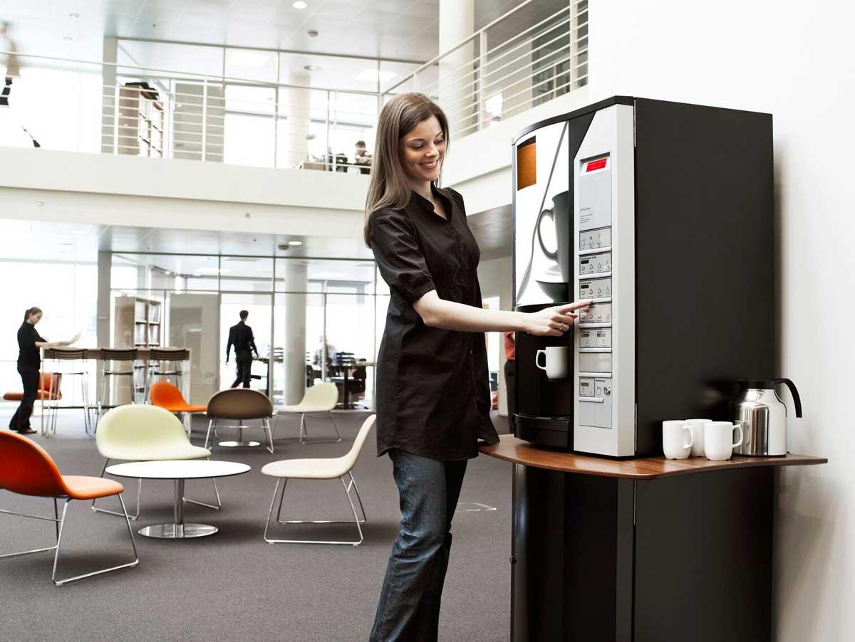

A company's experience with vending companies is the main thing that a business entity should be aware of. The vending supplier will determine if your business is a good fit. The vending supplier must be evaluated in the same manner. Before signing the deal, the business entity must examine the entire working environment and other factors of the vending firm. A company's time on the market is often a good indicator of its functioning. But it doesn't mean that it will be of greater benefit if a company has more experience than an entity new to the industry. Most important are industry experience, knowledge, and resources. It is better to seal the deal with a new vending company if they have these characteristics. In addition to this, the business should verify the number of services offered by a vending firm. If a company is able to offer a wide range of services, it will ensure that they have a large customer base. The number of services offered is also an important criterion, much like experience.

Popularity of a vending machine is dependent on what items are offered. A vending machine's popularity is directly related to the products it sells. Some local companies specialize in a certain brand, while others offer information on multiple brands. Each company will have a preferred flavor. Before signing a contract, business entities must express their desire for a particular flavor. Business entities are primarily affected by whether a flavor is available. It is best to change to another vending business if the vending vendor does not have your preferred flavor. For running a vending company successfully, multiple logistics are needed. The vending company should have central management software that manages all details. Central software can make an entity unique. This is why it is important to select automated services. In summary, it is important to note that finding the perfect vending company is no easy task.

