Learn What A Professional Has To Say About The Wedding Lighting

Lighting is essential for setting the mood and creating enjoyment at weddings. Lighting is essential for uplifting the spirits of guests and instilling enthusiasm. A lot of people don't pay enough attention to lighting, which is an essential aspect of wedding planning. Many people are unaware that adequate lighting can make or break a wedding. For perfect photos, it is important to properly light the wedding ceremony. It is worth mentioning that lighting has many purposes. A well-lit space adds ambience and atmosphere to make the event memorable. The wedding lighting is an important part of the overall decor. It adds color and life to the space. The dance floor lighting creates a mood and encourages people to move. Generally, the venue is decorated as per the lighting, and thus, it has a vital role to play in the entire wedding planning. The aesthetics of the wedding venue can be enhanced by the use of lighting, regardless if there are any customs or traditions. Wedding lighting is often focused on small details that are meticulously planned out.

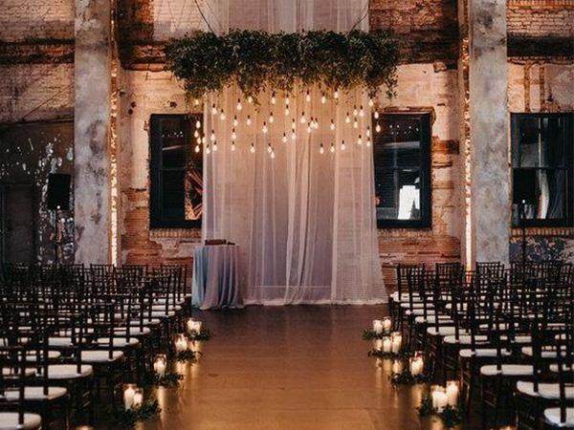

Proper lighting is also important for photographs. Lighting is crucial and should not be compromised. If you are unsure of the best lighting or related themes, it is worth hiring a professional wedding lighting designer. Today, lighting service providers have enjoyed great success. There are many options to choose from. You can choose the lighting according to the theme or time of your wedding. The venue is an important consideration when choosing lighting. Many lighting options are on the market today, as mentioned. Researching the best lighting options for your wedding is a great way to narrow down the choices. If the goal is to illuminate the tables with pin spot lighting, this is a good option.

The spotlight, on the other hand is a great option if you are only trying to highlight an object or an area. There are many other options, including string lights, texture lighting, uplighting and many others. Therefore, in a nutshell, it is ideal to mention that wedding lighting holds an important place in the overall wedding decor itinerary. Each option of lighting comes with its own price. It is therefore important to compare the prices when selecting the lighting option. Moreover, it is suggested that one must get quotes from different vendors so that everything sets in budget. Additionally, wedding planners are the ideal audience for getting a review or advice. Make your wedding memorable and unforgettable by choosing the right lighting options. Check out the following website, if you're searching for additional information about wedding lighting hire.

