Individual Guide On Wedding Entertainment

It is not easy to host successful events. Many people make costly mistakes, which can result in poor guest experiences. Live entertainment can make an event unforgettable. Live entertainment adds a special touch to your event and keeps everyone engaged. Many of them offer multiple services to their clients, which helps to create memories that will last a lifetime. One of the main reasons for live event performers' popularity is their ability to keep your party from getting boring. Many people wish to attend events but do not want to socialise. This is why so many events end up being boring and guests don't know what to do. Event hiring can help you add a unique touch to your wedding. They help clients create the perfect atmosphere and ensure that everyone has fun. The best live entertainment performers are exceptional actors who are skilled at what they do.

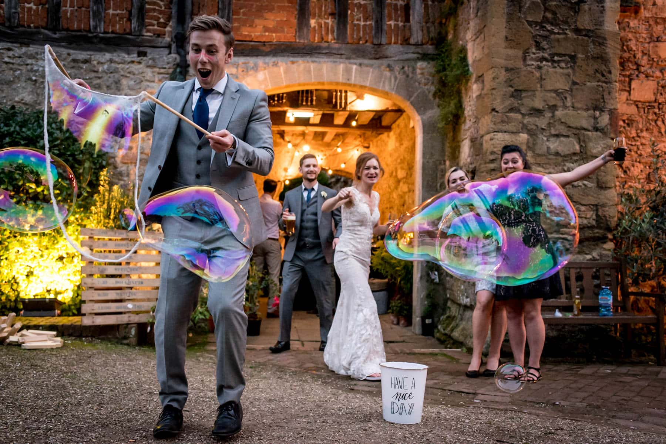

Often, the host knows all their guests but the guests do not know each other. A party mood encourages people to interact with one another and creates lasting relationships. Live performances help people feel relaxed and don't force them to speak with others. This takes the pressure off the hosts' shoulders, and they can focus on other things to make their event successful. Live performers can also be a great way to get guests to stay for longer periods of time. Many events don't succeed because guests leave early. Having live performers entertain your guests will allow them to spend more time at your event. Live performances are gaining popularity because they can offer many different styles of entertainment to their clients. If you're looking for additional info on wedding magicians, explore the earlier mentioned website.

You have the option to hire a range of performers for entertainment, including singers or martial artists, as well as magicians and dancers. A reputable entertainment agency can help you choose the right performance act for your event. They will work closely with all artists. Many people feel hiring live performers is too expensive. This is a common misconception. However, you can find many live entertainment companies offering services that suit all genres without causing a dent in your savings. They offer various event packages and assist clients in selecting services to fit their budget. They are familiar with performing at many events. They offer life insurance for their artists, so clients do not have worry about any unexpected events. Adding live entertainment to your event will motivate guests to stay longer and increase audience engagement. This is the best approach to making your event successful, and earning validation from guests.

