Event Venue Hire - An Overview

You want your guests to be able to recall your event. Professional event venue hire service providers offer the expertise to their clients to hold successful events and enable them to leave a lasting impression on their guests. A large space is essential for hosting events. Many people host events in their homes, which causes inconvenience to event attendants. Events should be held in open spaces to ensure comfort for your guests. Sport clubs are incredibly well-equipped to host numerous occasions. You can choose to have indoor or outdoor enclosures, depending on your budget. One of the most significant advantages of hosting events at professional venues is making your function memorable.

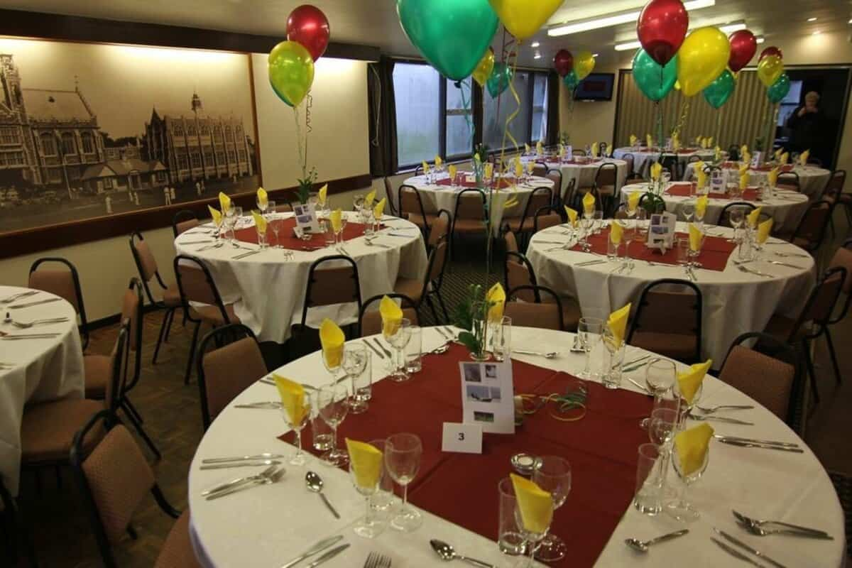

Your guests will remember your event for many years. It is important to provide a wonderful location for your guests to make an event memorable. Many people are able to plan well but have trouble finding the right space for their event. If you want out of the box ideas and add a new twist to your event planning, you can opt for professional event venue service providers. They will provide the best possible visual experience for their clients. The event venue rental service providers can customise their services according to customer requirements. Contact them to reserve space based on the number of people attending your event. A professional venue rental company has staff that can assist clients in planning and executing successful events. A professional venue will take care of all the cleaning after your event. If you are looking to learn more about event venue hire Watford, go to the previously mentioned site.

The most common tip to make your functions successful includes selecting the location that suits your event's theme. Many companies hire professional event places to host corporate dinners, presentations and office meetings. It leaves a positive impression on investors and event attendees. It will encourage your guests to attend your function in a visually appealing place. You will also notice a greater number of people attending your event. Your event will attract more people if it is held at a stunning location. A change in scenery can refresh your guests and allow them to have fun at the event. This is why it is important to choose the right venue for your event. You can also rent a space for any duration and pay according your needs. A venue hire company can make event planning easy.

