Detailed Report On Micro Market

Vending machines are an essential part of any company office. Before installing the machine, it is imperative to find a perfect vending machine supplier. A vending machine supplier provides vending machines for businesses. Internet access has opened up a world of vending options to individuals. Therefore, it makes the individuals quite puzzled. Additionally, there are many vending machines on the market. It can be hard to choose the right one for your needs. Before purchasing a vending device, you should consider these factors. It is also important to choose the right vending machine supplier to provide long-term and better services. While selecting a vending machine supplier, it is essential to conduct adequate research. If you are seeking for additional details on micro market vending machine, click on the above site.

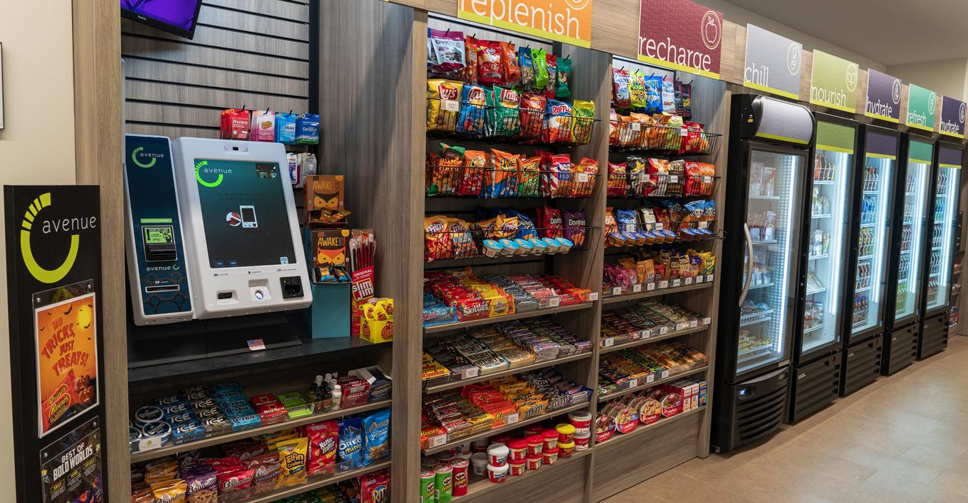

Although there are many providers who offer vending machine services, it is up to you to make sure that they are top-notch and free of any bottlenecks. When looking for a vending machine provider, it is crucial to research his past experience. An important part of a supplier's experience is how much he knows the market. The more experience a supplier has, the better their skills and knowledge will be. But if a supplier has never been on the market before, one might look at other aspects of the supplier's experience. Customer reviews generally refer to the feedback and responses that the supplier receives after it has provided its services. If the supplier enjoys a positive response, it is best to consider them. On the other hand, if there is a high percentage of negative responses from a supplier, it would be a great idea to look for another vending machine provider.

Furthermore, every vending machine supplier has a list of potential customers. If the list is extensive, it is highly advantageous to have such a vendor provide services. Currently, many vending machine suppliers have tie-ups with some well-known brands. It is essential to check that the supplier can supply the item you need. It is important to inform your vending machine provider if you intend to offer a certain brand of beverage. If the requested product isn't available at the supplier, it's best to switch to another vending machine provider. Because it is a custom demand, this feature is not available with all suppliers. Important logistics are required for efficient operation of vending machines. Additionally, they need to be maintained. Vendors must provide exceptional services as well maintenance. Businesses must evaluate the costs before signing a deal to purchase vending machines from a supplier. Vending machines are an asset that a business can use and should therefore be purchased from a trusted vendor.

