A Peek At Cost Of Party Wall Surveyor

The party wall surveyors play a vital role in any construction project. The surveyors serve to protect the interests both of adjacent owners and building owners. An experienced and skilled surveyor is able to resolve any disputes that may arise during construction. In addition to this, party wall inspectors have the sole goal of ensuring that the construction process proceeds smoothly and safely. Selecting an experienced and knowledgeable party wall surveyor is essential because every individual needs to comply with the regulations laid down in the Party Wall Act 1996 before starting any construction work. A professional party wall surveyor is the one who holds a complete APC, i.e., Assessment of Professional Competence. The goal of APC is to ensure that the candidates are highly professional and are well-versed with the rules of the Party Wall Act 1996.

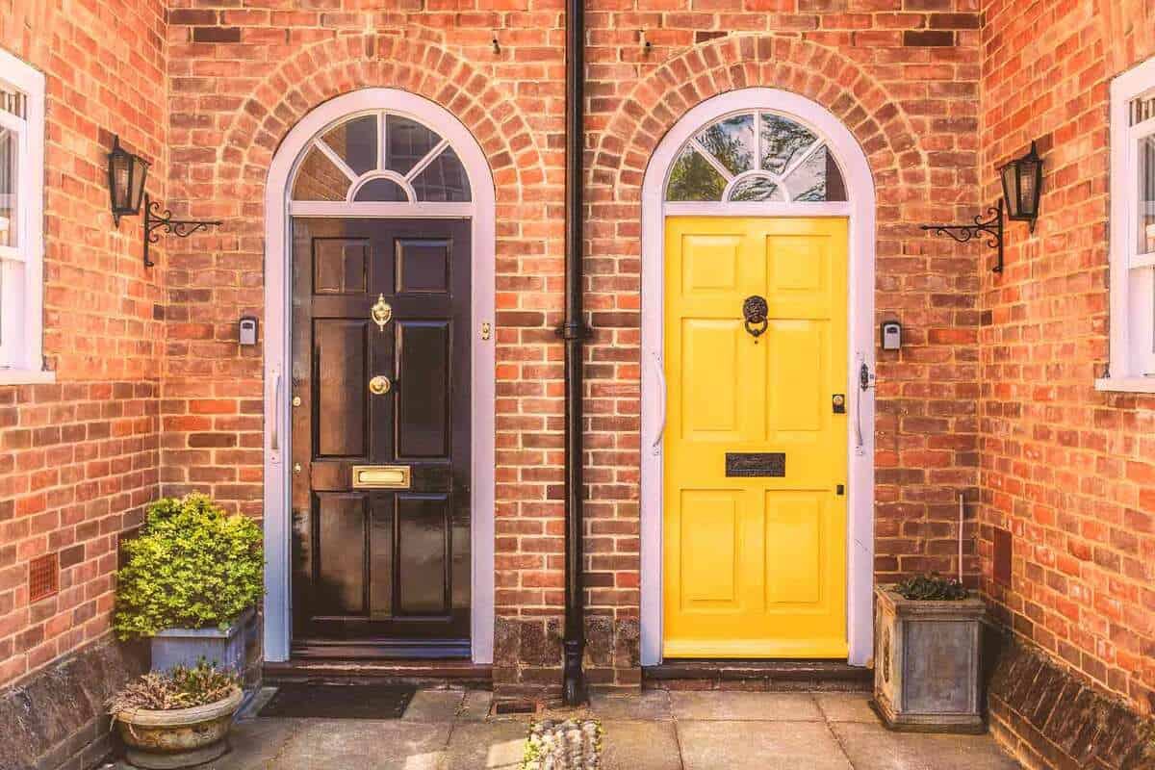

The practice of high-end, professional work can take many years. Individuals and building owners need to be open-minded when searching for party wall surveyors. To ensure the highest quality of work, a skilled surveyor should be hired. A skilled surveyor offers the best and most efficient services to people. An award for party walls is given to a party wall expert. Therefore, the individuals must consider the award before hiring a surveyor. Everyone has different needs and wants. The individuals need to consider the type of services and expertise the surveyor can offer before they appoint him. Every document should be understood and communicated to the surveyor. Therefore, every document must be carefully analyzed and evaluated by the surveyor. Inadequately interpreting a document can lead to legal problems for the individual. Are you looking for find a party wall surveyor? Visit the before talked about site.

Party wall surveyors should be familiarized with the method statement. The statement provides a detailed insight into the overall work. The statement details the work to be done and the dates they will be completed. The act's rules and regulations require that the surveyor perform all necessary steps. In order to draft a complete document, it is important that the party wall inspector has a good understanding of these documents. As they play an important role in the entire construction process, it's crucial that you hire a competent party wall specialist. Untrained party wall surveyors cause massive damage to the overall construction process because they are unaware of multiple rules stated in the act. Moreover, such surveyors also charge high fees from their clients. It is essential that individuals consider hiring a skilled, experienced, professional and qualified party wall surveyor when appointing one. They are efficient and provide the best service without any extra charges.

