A Few Details About Wedding Lighting Hire

Weddings are a very important event in a person's life. Many people plan their wedding months in advance to make it memorable. While lighting and sound effects are important for creating a memorable wedding atmosphere, many people do not have the equipment they need. If you're looking for a unique experience, you might consider hiring a lighting company. Many companies offer sound and lighting rental services to help clients make their events a success. People have many creative ideas, but they do not have the knowledge or equipment to properly light them. No matter what your event type is, adding lights can create a beautiful atmosphere and give your guests something to talk about. You can select among many lights, including lantern lights, customisable lights, star-shaped, mood lights and many more. These lights can also be hired depending upon the duration of the event. These professionals have the expertise to successfully execute events. The right lights can help create a magical atmosphere. Your event can be memorable by adding coloured lights.

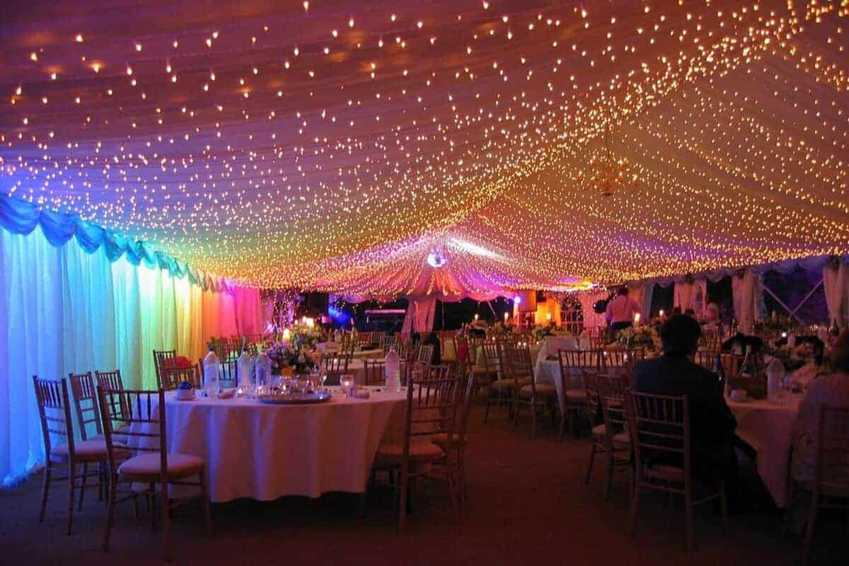

It is a great way entertain your guests. It saves money because people don't have to purchase expensive sound and light equipment for their weddings. You can just hire the lights and add life to your party. Professional light providers know what the client wants before they suggest products. To see their complete list of included lights, visit their website. Many lights come with a transitional mode that allows you to create multiple visual effects. The people can share their ideas with the sound and light equipment suppliers and make sure that their events run smoothly. Hiring professional light providers has the advantage that they take into consideration their customers' needs and preferences while organising events. They can help you find the right lighting solutions for your family's wedding or other events. They can help you combine several types of lights to create a beautiful atmosphere. Browse the below mentioned website, if you are hunting for more information concerning lighting hire.

They can help you sync the lights to the party's mood. Many times people either don't get the lighting they need at their local shop or spend a lot of money on expensive lights that can be damaged during events. This could cause embarrassment for the organizers of the event. Proficient lightning providers provide excellent customer service and support their clients in executing successful events. They can be reached if you experience any problems with your lighting or if there is an error. They are skilled in their work and have assisted numerous people with their events. They will be happy to provide lighting recommendations for your specific function. They have a wide range of products and can help you select the right colours to create the perfect atmosphere for your event. Lighting experts offer lights for both indoor and outdoor functions.

