Details About Weight Loss Retreat For Girls

Women can find mental and physical health solutions at wellness retreat centres. Due to their hectic lives, many women don't have the time or energy to take care of themselves. With so many responsibilities getting piled on, ladies cannot focus on health and suffer from several health problems like hypertension, stress, depression, weight gain and heart diseases. Many women believe they can lose weight by joining a gym, or going on crash diets. While this might work for a while, you might reach your original weight after you stop exercising. Women wellness retreats are designed especially for women. These wellness retreats are a great way to recharge your mind and body. These wellness retreats offer a safe and relaxing place for clients to take care of their health and learn from others. One of the greatest reasons to seek the help of women wellness retreats, is that they help people improve their mental health as well as their physical fitness. Visit the below mentioned site, if you're searching for more details regarding weight loss boot camp in the uk.

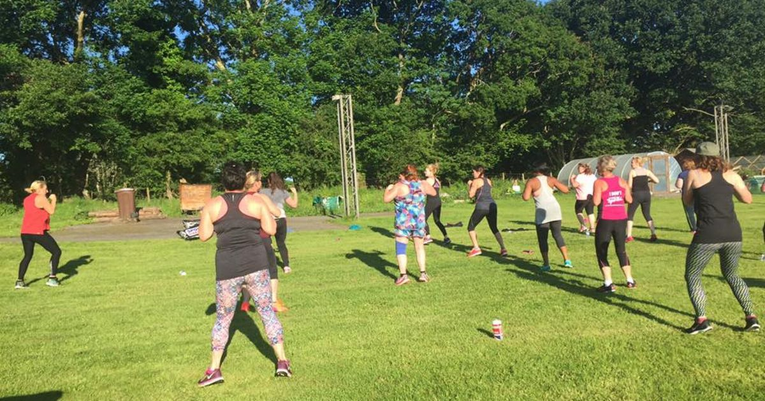

Women can suffer from low confidence and post-marital depression despite losing weight. They can get counselling and help improve their mental health. They can re-connect with their inner self, and take a break away from their daily responsibilities. Every retreat is designed keeping a health goal in mind, and you can discuss your body issues with people before beginning your fitness journey. A team of experts will help you identify reasons your clients are not able to lose weight or what issues they have in their lives that are affecting your health. Women wellness retreats for women are found in exotic locations that offer stunning natural views. Feeling connected to nature can help you feel reconnected and create a sense of calmness and freshness. Many people are unable to lose weight simply because they lack the mental strength. A wellness retreat enables people to discover their cognitive strengths and cuts down excess distractions.

Focus on your goals and allow yourself to reflect. Women wellness retreats are a way for women to connect with the natural world and receive healing. One of the main reasons people fail to lose weight is their unhealthy lifestyle. You can lose weight by connecting with nature and making small changes in your lifestyle and diet. Women wellness retreats have experienced and knowledgeable staff prepared for all situations and cater to all their clients' needs. They offer clients a chance to improve their health through a client-centered approach. You can contact them to find a tailored service that meets your needs. Many people think women's wellness retreats are expensive but this is a wrong notion. Wellness retreats have the best interests of their clients at heart and work for their benefit. You can opt for several activities like meditation, diets plans, wellness training in your health retreat.

