Facts On Cool Paintball Masks

Paintball marker is an important piece of equipment used after the paintball safety mask. A paintball marker is exactly like a paintball gun. There are a variety of models of paintball markers in the market. Some are inexpensive, and some are expensive. They're a massive range of paintball markers with their choices. Each paintball marker works differently from other people. The best paintball markers comprise of excellent material and quality. It is very important to pick the best paintball marker for your safety. You can ask your friends who have paintball markers. You can also visit paintball blogs and forums for more information. Paintball business is continuously growing competitive also. There are several manufacturers that provide high-quality markers. These paintball markers require less maintenance to be able to provide them with a lifetime. Visit the following site, if you are hunting for more information about cool paintball masks.

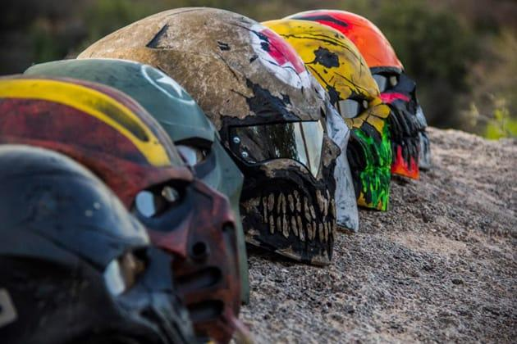

It will keep the paintball equipment in working order. Regular oiling of this paintball marker is very important for its maintenance. Regular maintenance of the paintball marker saves your time and money. There are various benefits of the best paintball marker. Firstly, these markers are durable and comfortable while playing. They are so versatile. Paintball marker may be utilised in any paintball tournaments. Moreover, paintball markers may be used only for outdoor purposes like wood games or other fake battles. Paintball is such a game that require a combination of skills. It is necessary for success in any game. Paintball is a game where concentration and sighting are very important. The most important thing is that you will be able to achieve your task just by practising. Best paintball marker is fully equipped with all the back and front sight. Paintball marker game is continuously growing with its popularity. This game can be played in various scenarios.

They're played in parks, woods, fields, bunkers, etc.. These scenarios have their own sort of paintball markers. This game provides an option to the beginners and experienced personalities. It must be noted that playing this game in the exterior area does not affected by the weather conditions. Paintball game like a paintball gun, paintball marker, paintball masks, etc.can be played by different ages. Children more than ten years may play paintball games but with strict principles and observations. This game also generated excitement and fun with people. Additionally, it requires leadership and great communication to have a successful game. Paintball markers shooting games can also be used to construct and improve the relationship inside the people. You will also find increasing popularity within the people. Many organizations, businesses and plenty of groups have found various benefits in this sport. All the members are attempted to communicate well through verbal and non-verbal. Leaders help their teams in achieving their targets.

